Lancashire Health & Social Care Sector: Baseline Review

Final


A report for

Lancashire LEP

CONTENTS

1 Introduction 1

2 Literature Review 2

3 Data analysis 21

4 Key Issues 51

5 Bibliography 52

Appendix A – Health & Social Care Sector: SIC Definition

Appendix B – Location Quotients in Health & Social Care in Lancashire LEP Districts

Introduction
  - The purpose of this report is to highlight the main findings from a baseline review of the health & social care sector in Lancashire. Research was undertaken in two strands: a literature review; and data analysis. The literature review outlines the current and future challenges facing the sector at both the national and Lancashire level, while the data analysis summarises the current situation using data on employment, businesses, population, student numbers etc.
  - The report represents the main output from Phase 1 of the research programme submitted to Lancashire County Council as part of developing a sector skills action plan for health. The main findings from the baseline review will inform subsequent phases of the work plan, which will focus on engaging with employers and skills providers to test the issues identified by the desk-based research and ultimately, will lead to the development of a fully evidenced action plan.

Structure of the report
  - The remainder of this report is structured as follows:
- Section 2 outlines the findings from the literature review, looking at: the current situation; supply side issues; demand side issues; future challenges; and a summary of what is being done to tackle some of the issues facing health and social care.
- Section 3 looks at the employment and business base in the area, as well as summarising demographic change over the next decade. The section also presents analysis of the Higher Education sector in Lancashire and the North West, drawing on information sourced from the Higher Education Statistics Agency. It also summarises findings from the most recent National Employer Skills Survey undertaken by the UK Commission for Employment & Skills.
- Section 4 presents a summary of the main issues to emerge from the literature review and data analysis, which can be discussed in further detail with employers and skills providers as part of the next phase of the work plan.
- Section 5 provides a bibliography of the documents reviewed as part of the literature review.

Literature Review

Introduction
  - Through its direct and indirect contributions, the health and social care sector is of significant importance for the UK economy and indeed, to economies at the regional level. This literature review will outline the current and future challenges facing the sector at both the national and Lancashire level. The section is structured under a number of different themes and where applicable, case studies are provided in order to highlight particular issues affecting the sector. The themes are as follows:
- Current Situation: Outlining issues such as an ageing population, the health of residents in Lancashire, specific issues around the social care workforce and also providing a case study on health amongst Lancashire’s BME population. While reference is made to different statistics in order to highlight certain points, full details on the current situation in terms of data on employment, businesses, population and student numbers etc. is provided in section three.

- Issues for Employers: Summarising issues such as the role of demographic change in shaping skills demand and workforce gaps in professions such as nursing and social care. Digitalisation is also likely to play an important role on the demand side and a case study is provided on this issue.

- Issues for Skills Providers: Looking at research/papers published by organisations such as the UK Commission for Employment & Skills, Skills for Care, Health Education North West and the Centre for Workforce Intelligence. A case study is also provided on the Lancaster Health Innovation Park, which represents collaboration between Lancashire’s learning and health institutions.

- Future Challenges: Including a look at NHS England’s Five Year Forward Plan and also providing a case study on the Lancashire North Clinical Commissioning Group’s Vanguard Site, which has been created to take control of the whole health and social care needs of an area within a single budget.

- Tacking the Issues: Giving examples of how different organisations are working to try and address the issues affecting the health and social care sector. At a Lancashire level, the case study of Morecambe Bay’s “Better Care Together” programme is highlighted as one such example.

Current Situation
  - As the health and social care sector looks towards the future, it faces a number of imminent and future skills and employment challenges which it must address. Many of these issues are relevant at the national level, such as how to treat the comorbidities of an ageing population with an ageing workforce, but some are specific to Lancashire, such as staff shortages, particularly in social care and also how to address high staff turnover rates. As health and social care institutions and professionals call for greater integration, some CCGs, such as the Lancashire North CCG Vanguard Site are leading the way and by creating a reformed system that will take responsibility for the whole health and social care needs of the population within a single budget.
  - Strategies such as the NHS Five Year Forward View set out a vision for the future of healthcare. Its purpose is to articulate why change is needed, what that change might look like and how we can achieve it. It describes various models of care which could be provided in the future, defining the actions required at local and national level to support delivery. It outlines how everyone will need to play their part – system leaders, NHS staff, patients and the public – to realise the potential benefits for everyone. It covers areas such as disease prevention; new, flexible models of service delivery tailored to local populations and needs; integration between services; and consistent leadership across the health and care system. The Five Year Forward View starts the move towards a different NHS, recognising the challenges and outlining potential solutions to the big questions facing health and care services in England. It defines the framework for further detailed planning about how the NHS needs to evolve over the next five years.
  - Like the majority of regions in the UK, Lancashire has an ageing population due to more people living longer. While people living longer and healthier lives is something to be celebrated, it places additional pressures on health and social care services. Between 2014 and 2021, all eight of Lancashire’s CCGs are expected to see growth of at least 13% in their populations aged 70 or over. With two thirds of hospital patients being over retirement age, NHS England’s chief executive Simon Stevens has highlighted the ageing population as the greatest challenge facing the health and care system.
  - Residents in Lancashire are generally less healthy than the national average, with rates of asthma and depression in the highest quintile in England. There are also significant health inequalities within Lancashire. The Health and Social Care Act 2012 recognised the importance of tackling health inequalities. Health inequalities between the most and least deprived 20% of people in Lancashire have widened or have remained static for a number of diseases. As an example, health inequality for diabetes sufferers increased significantly between 2009 and 2013. As well as faring poorly on the national scale, there are wide variations in disease prevalence within Lancashire too. One Lancashire Clinical Commissioning Group (CCG), Fylde and Wyre, is among the worst 10% of CCG areas in the country for the prevalence of 15 out of 22 major diseases, while Chorley and South Ribble is not ranked among the worst decile for any.
  - A recent report by Skills for Care shows that the adult social care workforce continues to grow year on year. It also highlights the increased pressure that will be stimulated by the ageing UK population, noting that by 2025 there will be an additional 1.5 million people aged 65 or over in England, while it is estimated that 1 in 3 babies born after 2013 will live to be 100 years old. A key factor in being able to meet growing demands on these systems will be a workforce with the right skills performing the right roles. There are an estimated 17,300 organisations involved in the delivery and organisation of adult social care. These organisations are made up of some 39,000 establishments.
  - The adult social care workforce remains one skewed in terms of gender with 80% of workers being female (this is higher still in direct-care providing roles). The workforce is also an older one with 1 in 5 workers being aged 55 or over. In terms of ethnicity, the workforce is predominantly white (80%), though over 1 in 10 workers hold a non-EEA nationality. Both ethnicity and nationality profiles vary considerably by region. However, staff turnover remains an issue in adult social care with an overall turnover rate of 25.4% (equating to around 300,000 workers leaving their role each year). It should be noted however that turnover is not uniformly high although it tends to be higher in the private sector and amongst domiciliary care providers.
  - The workforce is the primary source of both current future health care costs. In the UK, 1.4 million people work in the NHS and as a proportion, the workforce accounts for around 70% of expenditure for the average health care provider. One of the biggest challenges for today’s professional workforce is that it was trained and developed to work in a model centred on single episodes of treatment in hospital. However, those placing the greatest demand on services, both now and in the future, are older people with multi-morbidities (both mental and physical), who need integrated, long-term health and social care.
  - Lancashire's population is less ethnically diverse than the national average, although large Pakistani and Indian communities are present in the sub-region. At the time of the 2011 Census, the largest ethnic group in Lancashire was white (92%) with the remaining 8% being from black and minority ethnic (BME) groups. This compares to 14% in England and Wales. Numerically, there were over 90,000 BME residents in the county and the proportion of BME residents has increased by around 50% since 2001. By ethnic group within Lancashire the changes varied greatly. The white population increased by just 0.6%. The Asian/Asian British population increased by 43%, the Black/Black British by 55%, Chinese by 69% and Mixed/Multiple by 71%. However, National Insurance number registrations continue to reduce, according to Lancashire County Council (2013), suggesting that new migrant numbers are decreasing. Almost three-quarters of the BME population of Lancashire live in Preston, Pendle, Burnley and Hyndburn.
  - Across the county council area 6% of all people said they had bad or very bad health. There are minimal differences in rates of people aged under 16 with bad or very bad health. However, by age 50 to 64 years almost 18% of Asian people are in this category. In the over 65 year olds age group, the rate was highest for Asian/Asian British older people, with almost 30% registering very bad or bad health compared to 16% of white people. Specific health risks within South Asian populations mean that the number of diabetes sufferers is likely to increase in the future. The relationship between social class and ethnicity and its impact on health outcomes is a complex one. Inequalities in health are multifactorial. They are influenced by issues such as environment, housing, educational achievement, material wealth, discrimination and lifestyle. As such, reducing health inequalities cannot take a ‘one size fits all’ approach and requires a multitude of efforts at different layers of society, engaging a wide variety of stakeholders.
Issues for Employers
  - The health and social care sector in the UK employs a wide range of professionals and practitioners, many of whom have undertaken extensive academic, vocational and practical training in order to meet the skill levels required to deliver high-quality health and social services. However, the high skill requirements of the sector also results in skills gaps and demands which are important to be addressed. Gaps identified by Skills For Health include:
    - In practical terms, ‘problem solving skills’, ‘oral communication’, ‘customer handling’, ‘teamwork’ and ‘management and leadership’ are key skills gap areas;
    - Shortages are so severe in 35 specific health-related roles that recruitment from outside the EU is necessary. These roles require very specialist levels of skill and are consistent across the UK.
    - Within the NHS, shortage pressure points exist within pharmacy [registered (5.3%) and pre-registered (6%)], other physiological sciences (7.6%), and respiratory physiology (6%);

  - A key driver of demand for skills in the sector is likely to be demographic change; the associated rise in long-term health conditions and the greater need for care for older people. Employment projections for the sector as a whole indicate that there will be a growing need for high level and caring skills at a time when growing demand is coupled with the impact of public sector spending constraints.
  - There are a number of prospective workforce gaps that represent challenges facing the health and social care sector. In England, many institutions are finding it increasingly difficult to recruit nurses, while the Royal College of Nursing projects that the number of nurses could fall by 28% (100,000) by 2022. In social care, the mismatch between supply and demand could reach 1 million workers by 2025, a 35% shortfall on projected demand. In the informal workforce (eg unpaid care provided by friends and relatives) the gap could be even greater. From 2010 to 2030 the number of people requiring informal care is expected to grow by 1.1 million to 3 million.
  - The mismatch between supply and demand is in part due to the ageing workforce and the subsequent demand that this will place on the sector. In 1996, 20.6% of nurses in the NHS were aged 50 or over; by 2005 the figure was 28% – a 36% increase, and a figure that is likely even higher today. As the workforce gets older, more nurses retire, which also means that the workforce loses technical and practical skills. Therefore, it is useful to outline some of the challenges facing the older workforce, and indeed, how these can be overcome in order to retain older workers. Challenges include: the physical toll of working and health problems associated with ageing, age discrimination and a failure to value experience by managers, extended financial and caring responsibilities for dependent children and frail older parents and nurses’ ability to gain access to retirement planning and flexible work options.
  - In addition, there are also a number of push factors causing older nurses to leave the NHS, notably reduced job satisfaction, dissatisfaction with career opportunities, insufficient educational opportunities and an inflexible approach to retirement. In order to overcome these issues, a number of policies and strategies have been proposed such as: the appropriate recognition and utilisation of skills and experience, tailored education and training, continuing opportunities for career progression and also flexible working conditions and approaches to retirement.
  - A paper by the Centre for Workforce Intelligence (CfWI) delves deeper into issues around GP numbers. The paper argues that growth in the GP workforce has not kept pace with the increase in the number of medical consultants or population growth. Boosting the number of GP trainees is proving difficult. Although fill rates have been high and there has been a modest increase in applications for GP training in the last two years, the number of accepted offers to GP training posts in 2013-14 remained below its 2010-11 peak. Another issue is the unequal distribution of GPs, whereby more deprived areas suffer from shortages more acutely. Therefore, simply increasing the supply of GPs will not necessarily lead to a more equal distribution, as several studies have found. Reducing geographical inequity in access to GP services requires targeted area-level policies, including increasing GP training opportunities in those areas with the poorest coverage.
  - Issues facing existing GP’s were also flagged by the CfWI. GP’s have argued that their workload is increasing, as consultation rates per patient rose by 41% between 1995-96 and 2008-09 largely due to an increase in consultations for patients aged over 60. Also, the GP role has become broader and more complex. Research indicates that the role of the GP has expanded over the past decade, with increasing and competing demands. A significant proportion of a GP’s time is now spent on non-clinical responsibilities, including working with the new clinical commissioning groups (CCGs). These additional responsibilities may be reducing the time available for direct patient care. Finally, they conclude that the available evidence suggests the GP workforce is under considerable strain and current levels of activity may not be sustainable in the face of rising patient demand.
  - As the modelling shows that current numbers of GP trainees are inadequate and are likely to lead to a major demand-supply imbalance by 2020, CfWI makes a number of suggestions for how to respond to this shortage. It estimates that a 20% increase in annual GP training posts from their current 2,744 to 3,280 are required by 2015-16. Regarding the job itself, both patient demand and practice operations could be managed more effectively. While the CfWI’s central recommendation is to boost workforce supply, there is considerable scope for GPs to improve ways of working as well. Possible solutions include: enacting changes to the general practice skill mix; reducing the number of missed appointments; increasing the use of technology to interact with patients; and managing back-office functions more effectively. Finally, there are other recommendations made in regard to how to mitigate short-term supply risks, and to bolster medium-term supply. These include making general practice a more appealing career choice for medical students, making it easier for trainees or established practitioners in other specialties to switch to general practice and reductions in non-clinical time spent by GPs on paperwork, reporting and administration, among others.
  - Depending on whether care workers are residential-based or domiciliary, the demands they face are different, especially in regard to the personalised care budgets of patients. In 2011 the Dilnot Commission published recommendations to reform the way individuals pay for their care and how government could provide better support. The Commission concluded that the current system was ‘not fit for purpose and needs urgent and lasting reform’. It identified that the current system is confusing, unfair and unsustainable, meaning people are unable to plan ahead to meet their care needs. In particular the Commission was concerned that: there is a ‘postcode lottery’ as eligibility for care varies between different local authority areas; people are often unable to move home as ‘care packages’ are not portable between local authorities; and the process of obtaining care, including getting assessed, is complicated and lacks transparency. People are unable to protect themselves against ‘catastrophic’ costs. Although the majority of people in later life do not face very high care bills a small number of older people are forced to pay out over £100,000. As there is no way to predict in advance who this will be and very few financial products available to help cover very high costs, care truly is a ‘life lottery’.
  - As a response to this, the Dilnot Commission made a number of recommendations, including that a cap of £35,000 should be placed on an older person’s lifetime contribution to their ‘eligible care needs’ in order to protect people from catastrophic costs. This includes both the costs of care received either at home or living in a care home; an increase in the means tested upper threshold for people applying for financial support for their care; and an end to the ‘postcode lottery’ for care through introducing a national eligibility threshold for England. These measures, the Commission believed, would significantly reduce the financial risk any individual would face and would mean no one would end up forced to spend all their money on care.
  - Another skills demand issue is related to the mismatch between the location of the current workforce and the locations where care services are needed. Part of this can be explained by what are described as ‘higher education coldspots’, identified by data from the Higher Education Statistics Agency (HESA) showing the areas with low concentrations of people studying. Areas in Lancashire do not fare well relative to that national average when it comes to the proportion of graduates. Blackpool and Preston have up to 0.9 relative to the UK city average (1), whereas the figures for Blackburn and Burnley are even lower at 0.5-0.8 of the UK city average.
  - In regard to the workforce demand issues related to doctors, CfWI is forecasting an oversupply of hospital doctors and an undersupply of GPs. However, although there is expected to be a large oversupply of hospital doctors generally, there will be significant issues in particular specialties, with emergency, geriatric and psychiatric medicine facing recruitment difficulties. Yet these are precisely the specialties where the need is greatest and growing most significantly, given the changing demographics and the need for consistent 24/7 care. The short-term fix to these issues is to employ significant numbers of agency staff, which is an unsustainable solution. Workforce redesign is needed not only because of a potentially dwindling workforce, but also because the nature of health care work is changing and the skills of the current workforce are not well matched to future needs.
  - As with the rest of the UK, the demand for health and social care services in Lancashire is growing as the population ages and people with ill health require more care. Across the sector, there are calls for much closer collaboration between specialists and generalists, hospital and community, and mental and physical health workers. The NHS and social care sector needs multi-skilled staff to work across these boundaries in an integrated fashion. Breaking down the barriers between different services is crucial if Lancashire is to improve both quality and efficiency of care, and to ensure a collaborative one-system approach. The aim should be to give individuals the care and support they require in the most appropriate and efficient settings and to ensure a truly integrated service.
  - Social care services also face particular challenges, with the proportion of temporary staff in Lancashire social care institutions being almost double the English average. In many parts of Lancashire, vacancy rates are also higher than the England average and have grown by 155% in the past three years - three times as fast as rates in England over the same time period. The Skills for Care National Minimum Data Set (NMDS) online database estimates that of the 212,000 social care jobs in the Northwest, 54.3% are in the private sector, compared to 16.1% in the voluntary and 12.1% in the local authority sector. These are slightly different to the England average, in which 57.2% of the jobs are in the private sector, relative to 19.1% in the voluntary and 9.2% in the local authority sector. The dataset also reports that in Lancashire, 64.7% of care professionals had been in their current job since 2010, 24.0% joined between 2005-2010, with 13.3% joining more than ten years ago. However, in the rest of England, 55.0% joined after 2010, and 28.7% joined between 2005 and 2010, meaning 22.3% had been in their current job role for more than ten years. This demonstrates that care workers in Lancashire had been in their roles for less time than care workers nationally. Knowing how long workers have been in their roles gives an understanding of staff stability and continuity of service. The longer workers have been in their roles the more time they have had to develop relationships with service users, to complete training and qualifications and to gain experience.
Issues for Skills Providers
  - At an individual level, the supply of skills comes from three sources: the investments that individuals make in their initial education and training before they enter the labour market; an individual’s investment in continuing professional development whilst in work; and the investments that employers make in developing the skills of their workforce. At the broader level, the state also fund skills development through payments to further education providers and subsidies to universities.
  - Since 2006, there has been an increase in the number of students applying for medical degrees, subjects allied to medicine and social studies. Recently however, this has slowed, or even reversed slightly. For example, whereas in 2011 there were 96,400 university applicants to medicine and dentistry, in 2012 this number dropped to 93,900 – a 2.6% decrease. For students applying for social studies subjects, the drop was even more pronounced, decreasing by 7.3% from 233,900 to 206,500 over the same time period. Alongside this, the number of medicine and dentistry qualifications has been increasing in recent years; however, given the relative stability in the number of acceptances given to students wanting to study medicine and dentistry, it may be difficult to maintain the recent increases in qualification attainment in these subjects.
  - Employers in the health and social care sector invest money in their employee’s skills at a higher rate than the UK average for other sectors, in part due to the tight regulatory environment requiring certain qualifications before staff are permitted to directly engage with patients. The UK Commission’s UK Employers Skills Survey 2011 reports that over 80% of employers in the health and social care sector provided training to their employees in the past 12 months. The average for all employers in the UK is 59%. There is also an increasing focus on the UK’s vocational education and apprenticeships system, particularly as a source of supply of intermediate technical skills. According to the Office of National Statistics, between 2002 and 2011, there was a 382% increase in the number of people starting apprenticeships.
  - Skills for Care believe employers should place greater emphasis on the training and development of their staff to ensure that they have a capable, confident and skilled workforce. Analysis of Skills for Care data (NMDS-SC) shows over two thirds of workers had completed an induction, while a further 11% had their induction in progress (through being new to their role). From April 2015 the induction was replaced by the Care Certificate - assessing the fundamental skills, knowledge and behaviours that are required to provide safe, effective and compassionate care. The certificate contains both knowledge and competence outcomes and allows learners to develop their new skills in a classroom or similar setting in preparation for the assessment evidence, which must be collected during real work activity. These changes might appear subtle, but they illuminate a seismic culture change that is clear in the Care Certificate excerpt from the technical document page three, under the heading “assessment”: “Evidence of performance must be undertaken in the workplace, during the learner’s real work activity and be observed by the assessor”. It will no longer be acceptable to attend induction, complete the workbook and start working alone shortly thereafter. After April next year, this practice must be checked - and with the people that workers support. Health Education North West has recently designed a toolkit to act as a guide for users implementing the Care Certificate.
  - As a response to the factors that influence the supply of employees to the health and social care sector, the UKCES argues that in order to address the skills and occupational gaps at the national level, there is a need to:
- Modify working practices and roles by reforming traditional approaches to provide greater flexibility, embrace new technology and deliver more appropriate patient care.
- Develop more new entry routes into the sector, for example through apprenticeships.
- Raise engagement to maximise productivity, retention and minimise absence.
- Ensure that skills shortages do not arise through reductions in migration rates, especially in light of government commitments to restrict immigration.
- Ensure that strategies are in place to replace the increasingly large cohort of retirees, especially those who are highly skilled.

  - To elaborate on the final point above, it is projected that 107,000 people will retire between 2007 and 2017. Replacing these professionals will be a challenge, it also represents an opportunity for employers to reshape their workforce and employment strategies to become better equipped to respond to future skills demands.
  - There are also prominent workforce challenges at the Lancashire level. Recruiting and retaining medical, nursing and specialist staff poses a significant problem, particularly in emergency medicine and accident & emergency departments, as well as specialties of growing importance, such as clinical and interventional radiology. In Lancashire, medical and dental staff turnover exceeds the England average. As a result of workforce shortages across the North West, there is a need to increase the number of GPs in training and practice to ensure that the supply and demand gap is closed.
  - The sector enjoys support from the universities in the region, such as Edge Hill, Lancaster and Central Lancashire universities, all of whom have a strong track record in research and development. An example of collaboration between Lancashire’s learning and health institutions can be found in the case study below.
Case Study: Lancaster Health Innovation Park
Lancaster University, together with Lancaster City Council and Lancashire County Council, is developing a Health Innovation Park on land currently allocated for a Science Park development adjoining the University.

The Innovation Park, which will be completed in 2018 will be expected to:
- Provide an integrated approach to healthcare and services for people who are growing older, as well as integrating and delivering an innovative combination of services applicable to urban and rural environments;
- Capitalise on the research profile, collaborative strengths and business linkages of the University;
- Provide research and development activities and raise the profile of Lancaster University as an excellent partner for collaborative research;
- Improve graduate retention in the area;
- Mutually enhance the image and reputation of the City, the region, the University and businesses.

Future Challenges
  - Many reports explore the challenges facing the sector and propose strategies and solutions to address them. For example, NHS England recently published a “Five Year Forward View” that offered a route map for the proposed direction of travel for the health and care system over the next five years. Much of the Forward View focuses on secondary care in hospitals, but it also recognises the importance of reforming primary care too. The challenges facing primary care include:
- An increasing workload and falling income
- Poor career structures and problems with workforce recruitment and retention
- Under-utilised skills and a lack of investment in education and training
- Lack of investment in infrastructure including premises
- The challenge of seven-day working.

  - Another paper, Think Big, Act Now: Creating a Community of Care also looks forward and sets out the NHS Alliance’s position with regard to the future of general practice and primary care. It aims to provide a starting point for a practical guidance system and orchestrated campaign to re-energise a tired and demoralised primary care workforce, especially within general practice. The desired outcome, they argue, is for general practice to be regarded as ‘special’ again and to encourage the general public to see it as such, whilst also inspiring a new generation of doctors, nurses and other health professionals to be part of a prestigious primary care service.
  - The report calls for a fundamental shift in thinking by all who interact with the health service – one that moves from the delivery of health care as transactional and process driven – to one that relies on relationships. It describes this as a responsive and responsible service with three underlying principles:
- A responsive and responsible system.
- A responsive and responsible health professional.
- A responsive and responsible patient.

  - In order to deliver these principles, the report articulates a number of points, some of which include recognition that a restructured workforce is needed to deliver change, a reduction in the bureaucratic workload, greater co-ordination with community healthcare services and social care, a review of core funding and embracing use of new technology. Importantly, there is also an acknowledgment that there needs to be a demedicalisation of care, where appropriate, and a recognition that a solely medical approach cannot solve underlying problems such as unemployment, inadequate housing and social isolation.
  - To create an effective and efficient health and social care workforce in the future, it will be essential to develop versatile teams, not just individual professional groups. Previous investments in workforce have been heavily weighted to individual professional groups, in particular medical and nursing staff. However, clinical staff work within multidisciplinary teams and the quality of teamwork is a major contributor to the quality of patient care. Developing teamwork skills may be more important than developing the roles of one professional group.
  - Medical training also needs to move away from the traditional individualistic perspective and prepare students for multidisciplinary team working. It is also important to align the workforce to work, not the other way round. It is not possible to separate workforce redesign from work redesign; both need to be undertaken simultaneously. There should be a drive towards ‘collaborative practice development’, rather than ‘continuing professional development’ – working across professions, not developing individual professions. Health and social care are team-based activities; the work of one team member is inter-dependent on others. An example of how this notion has been successfully implemented in Lancashire can be found in the following case study:
Case Study: Lancashire North CCG Vanguard Site
With a population of 365,000, the partners of this Vanguard are all members of the Better Care Together Programme (see page 17), working on behalf of the population of Morecambe Bay which has 365,000 residents. They include five NHS Trusts: University Hospitals Morecambe Bay NHS Foundation Trust; Cumbria Partnership NHS Foundation Trust; Blackpool Teaching Hospitals NHS Foundation Trust; Lancashire Care NHS Foundation Trust. The Vanguard also includes North West Ambulance Service NHS Trust (NWAS) and two NHS Clinical Commissioning Groups: NHS Lancashire North Clinical Commissioning Group and NHS Cumbria Clinical Commissioning Group.
Two local authorities, Lancashire County Council and Cumbria County Council are also in the Vanguard, together with two GP Provider Federations, the North Lancashire Medical Group and the South Cumbria Primary Care Collaborative. The Vanguard will create a system that will take responsibility for the whole health and social care needs of the population within a single budget. This will mean a smaller, more productive hospital service working hand-in-hand with integrated out of hospital services. It will focus on keeping individuals, families and communities healthy, developing capacity in general practice and community services, and focusing the hospital on the services only it can deliver. This means that patients who work full time, for example, should have greater access to services at times that suit them, as the Better Care Together programme will develop more services and capacity in a setting closer to patients’ homes.

  - As part of their report exploring the composition of the future of the healthcare workforce, Skills for Health discuss how the health service will need to be restructured in order to respond to the challenges of the future. With a focus on professional skills, the author (like many others) concludes that an ageing population will change the levels of demand placed on different aspects of the healthcare system. For instance, more people will be living with chronic illnesses, rather than dying from them, meaning that certain healthcare sectors, such as for diabetes treatment, will require greater numbers of staff, particularly skilled staff.
  - In addition, with demand for services rising faster than funding, a squeeze on resources will mean that healthcare sectors will be required to do more with less. As a further consequence of funding cuts, pressure on resources will require professionals to demonstrate value and results in the care they deliver. This will necessitate many to take a leadership role, improve the process of care and be accountable for spending. Finally, the exponential rise in medical information and knowledge means that professionals will need to be expert knowledge managers and navigators and make much greater use of information technology. The role of information technology within the sector is a key issue and the case study below looks at this in further detail, in the form of a case study on digitalisation and its potential impact.
Case Study: The Digitalisation of Healthcare
The nature of health and social care is changing rapidly, and therefore embracing and integrating digital technologies into healthcare provision is increasingly integral to ensuring that industry professionals are equipped to adapt to these changes. A major advancement in health and social care in recent years has been the digitalisation of clinical, patient and administrative records, which has made recording information more efficient, cheaper and of higher quality. In addition, health informatics and metadata are being progressively adopted into the patient diagnosis procedures and are also being used to both review patient care strategies and pre-empt the necessity for and timing of interventions.
A number of pieces of research have underlined the need to embrace new technology. An example is PwC’s Health Research Institute (HRI), which surveyed 1,000 physicians and physician “extenders” and found that increasing digitalisation can:
- Help caregivers work more as a team
- Increase patient-clinician interaction
- Put diagnostic testing of basic conditions into the hands of patients
- Promote self-management of chronic disease using health apps.

In their report exploring healthcare delivery models of the future, PwC project that healthcare digitalisation will be: focussed on the patient as a consumer; predictive and precise; integrated and transparent; team-based; sustainable; quality-based and efficient. To achieve this, a number of measures have been proposed or are already underway. One advancement that is being developed is the notion of clinicians and patients connecting digitally, rather than face-to-face - freeing up capacity by replacing in-office patient visits.
New medical and information technologies can enable different ways of working, including enhanced roles for patients. Technology puts power into the hands of patients and means more care can take place outside the hospital setting. Instead of spending many hours attending busy outpatient clinics to have their blood monitored and medication adjusted, patients can test themselves and either adjust their medication according to a predetermined dose or call a clinic to be told the appropriate dose. However, while use of these technologies can improve clinical outcomes, and make care more convenient, it is important to note that not everyone feels confident to self-medicate or will want this degree of intrusion in their daily lives.

The ‘Digital by Default’ agenda set out in the UK Government’s Digital Strategy sets a target for all public services to be delivered online ‘by default’. It also mandates the provision of ‘consistent services for people who have rarely or never been online’. Skills for Care (2014) report that considerable resource is therefore being dedicated to the continuing issue of digital exclusion, which sees 11million people in the UK lacking basic digital skills and therefore potentially excluded from accessing public services. The Department of Health’s ‘Digital First’ strategy focuses on the internal requirements for the Department to become more digitally effective, and on the effect of digital technologies on the provision of information, including a commitment to ‘steward the health and care system towards a health information revolution’.
Available data suggest digital technology is well embedded for professional and managerial staff, but not for the remainder of the workforce. Only a quarter of social care staff say they access the internet for work. Both of these strategies underline the importance of improving access for patients and healthcare professionals alike, if the advantages of digitalisation are to be realised. Social care sector literature foresees that assistive technologies will spread rapidly across the social care sector, and this will hasten a requirement for all staff to have some degree of digital capability. With that being said, there is evidence to suggest that social care employers see the set-up costs of digital technology as a barrier to further uptake, particularly those in SMEs.

  - As outlined in the previous section, in the future, new technology, pharmaceutical advances, genetic engineering and emergent evidence-based medical and nursing practice requires the healthcare sector to develop new ways of working with an ageing population that will have more complex co-morbidities, be more aware of their care needs and have growing expectations of what the care system should deliver them.
  - The ‘Raising the Bar’ report published by Health Education England delves further into the issue of reforming working practices by looking at the future education and training of nurses and care assistants. It notes that care assistants, be it in health or social care settings, are a vital part of delivering frontline compassionate care. They currently provide approximately over 60% of hands-on care, yet often have little access to training or personal development. They must be a significant focus for investment because they are of vital importance to patient safety and wellbeing. To achieve this, it is essential that registered nurses feel valued throughout their whole career. Furthermore, as nurses increasingly engage with health and social care research (and indeed are in a unique position to do so), it is essential that nurses have the ability to engage in critical enquiry and implement research findings in order to make a significant difference to the care experience.
  - ‘Raising the Bar’ concludes with eight overarching recommendations, which advocate: enhancing the voice of the patient and the public; valuing the care assistant role; widening access to care assistants who wish to enter nursing; developing a flexible nursing model; assuring a high-quality environment for pre-registration nurses; assuring high-quality, ongoing learning for registered nurses; assuring sustainable research and innovation; and assuring high-quality funding and commissioning.
Tackling the Issues
  - There are a number of reports from various health and social care governance organisations that outline ways of tackling the myriad skills and employment issues affecting the sector. For instance, in No Health Without Mental Health and Closing the Gap, the Government set out its commitment to achieving parity of esteem for mental health. Timely access to services and then for treatment is one of the most obvious gaps in parity – whilst there are waiting time standards for physical health services, for mental health services, these standards don’t exist. This plan sets out the immediate actions to be taken in order to end this disparity and achieve better access to mental health services, along with a vision for further progress by 2020. In 2014/15, an estimated £40 million investment was due to be made – comprising:
- £7 million to end the practice of young people being admitted to mental health beds far away from where they live, or from being inappropriately admitted to adult wards.
- £33 million to support people in mental health crisis, and to boost early intervention services, that help some of the most vulnerable young people in the country to get well and stay well.

  - A further £80 million investment is scheduled to be made in 2015/16 with the following targets in mind:
- Treatment within 6 weeks for 75% of people referred to the Improving Access to Psychological Therapies programme, with 95% of people being treated within 18 weeks.
- Treatment within 2 weeks for more than 50% of people experiencing a first episode of psychosis.
- A £30 million targeted investment will help people in crisis to access effective support in more acute hospitals.

  - Only three quarters of patients with mental health problems are receiving treatment within 18 weeks of being referred by a GP, compared to 95% of those with physical ailments, according to a an analysis of data by the Nuffield Trust. Speaking in relation to Scotland, Liberal Democrat Health Minister, Jim Hume points out that ‘two-fifths of GPs are not referring patients to psychological treatments, either because of the ballooning waiting times or just lack of provision. It's not just me saying this, it's the GPs themselves’.
  - Last year, the Department of Health also outlined their proposal to transform primary care into a safer, more proactive and personalised model of care directed at those who need it the most. It argued that the NHS and social care services need to change to meet the challenges of an ageing population and to better serve those living with complex health and care needs. This means providing personalised, proactive care to keep people healthy, independent and out of hospital. It also acknowledged that to achieve this, a requirement is the support of a wide range of NHS and other staff, working in partnership with other local partners .
  - This proposed transformation comes in response to feedback from patients, who feel that services are disjointed and the system is failing to meet their needs. The initial focus for the transformation of primary care therefore, is on the people with the most complex needs. From September 2014, over 800,000 people with the most complex needs began to experience a change in their care, with GPs developing a proactive and personalised programme of care and support tailored to their needs and views – the Proactive Care Programme. In addition, in an effort to improve continuity of care, by the end of June 2014, all people aged 75 and over were assigned a named GP with overall responsibility for and oversight of their care. This accountability, it is thought, will help coordination of services around the patient, ensuring personalised, proactive care regardless of the setting.
  - Another facet of the Proactive Care Programme is increased support to health and care staff through the ‘freeing up’ of staff, particularly GPs. In addition, training is required by staff to ensure they can improve their skills to meet people’s changing needs and work across traditional boundaries. Health Education England will support joint working, and engage with employers, professional bodies and education providers to ensure the workforce has the necessary skills to care for older people and those with complex needs. Health Education North West have also looked at this issue and established a dedicated workforce transformation function in January 2014. In support of the increasing impetus for whole system service transformation the Workforce Transformation Team’s primary purpose is to develop a workforce responsive to changes in care, now and in the future.
  - DH’s ‘Transforming Primary Care’ report contends that in order to support this vision, the system needs to enable, rather than restrict, the transformation of services. DH is planning to make available an extra 10,000 primary and community health and care professionals by 2020, in support of the shift in how care will be provided. Furthermore, clinical commissioning groups will provide £250 million to commission services to support GPs to improve quality of care for older people and people with the most complex needs. Also, from 2015 onwards, the £3.8 billion Better Care Fund will support the integration of health and care services. An example of how the sector is showing signs of reform comes from Morecambe Bay, in the following case study.
  - Some commentators have pointed out that it is imperative that the sector better recognises that the staff it will have in the future are the staff it already has today. Therefore, any workforce redesign needs to focus more on re-training or re-assigning/re-purposing the current workforce, so that they have the skills needed to deliver new models of care, rather than on the training of new junior medical staff. Currently, less than 5% of the £5 billion Health Education England training budget is allocated to continuing professional development, while the rest is spent on securing professional qualifications; this division should be reconsidered.
Case Study: Morecambe Bay – Tackling the Issues
The health and social care organisations that deliver services across Morecambe Bay have united under the banner of the “Better Care Together” programme to co-design high quality adult, children’s and mental health services that will be safe, affordable and fit for the future. At the heart of the strategy is a “population” based approach to promoting wellbeing and providing care in which people and their needs are the focus rather than processes and buildings. People will be enabled to make lifestyle choices that will keep them healthy for longer and to take control and manage their long-term conditions with local clinical teams integrating the support and technology they need around them. This will include more effective use of video links, texting and other digitalised facilities which will reduce the need for patients to travel, whether from their own or their nursing care home.

The Five Year Forward View published by NHS England echoes Morecambe’s proposals for integrated out of hospital care built upon GP practices, supported by specialist teams. The team in Morecambe want to provide the best possible care within the realities of the budgets available to them and recommend the Better Care Together Strategy as a credible and innovative way forward for their local health economy. Five delivery principles have underpinned the development of the programme:

- Focussing on a patient’s experience, rather than organisational interests.
- Engaging with patients & stakeholders from programme conception to identification of the preferred clinical model.
- A clinically led solution from start to finish.
- A robust qualitative & quantitative framework to underpin the options.
- A focussed governance process to drive the process and hold it to account.

  - Another issue that requires greater attention is the support the informal workforce In England, for which around 3 million people volunteer in health and social, and there are more than 5.5 million informal carers. This is almost three times the number of formal health and social care workers. With more and more fit retirees, there is an opportunity to foster a ‘social movement’ to support those in need.
  - The health and social care system is under extreme pressure to improve the quality and efficiency of services. To meet the challenges ahead, service providers will need to think differently about how they work and who they work with. Research indicates that volunteers improve people’s experience of care, building stronger relationships between services and communities, supporting integrated care, improving public health and reducing health inequalities. The support that volunteers provide can be of particular value to those who rely most heavily on services, such as people with multiple long-term conditions or mental health problems.
  - Voluntary sector organisations are providing a growing range of public services, bringing volunteers into new aspects of service delivery. Innovative forms of volunteering such as ‘time banking’ and peer support allow community members to act as both the beneficiaries and the providers of care. In some hospitals, volunteers are increasingly being seen as an integral part of the care team. There are huge opportunities for volunteering to help transform health and social care services and bring about real improvements for patients and the wider public. The challenge now is to ensure that the system can make the most of these opportunities. Many organisations lack a strategic vision for the role of volunteering within their workforce, and so miss the opportunities that exist. The value of volunteering needs to be better measured and articulated at all levels in the system. There is a striking lack of information about the scale or impact of volunteering in health and social care.
  - Critics have argued that there is a need to reverse the ‘inverse training and investment’ law. Much of the workforce debate has focused on the most expensively trained workers. Approximately 60% of the NHS’s training budget is spent on the most highly paid health professionals (12% of the workforce) and 35% is spent on nurses and allied health professionals, who account for 40% of the workforce. Despite the fact that biggest growth in need will be in hands-on, out-of-hospital, and social care, there are no national funding streams for training the unqualified workforce, such as health care assistants, who have no real professional pathway.
  - Finally, The King’s Fund discuss the need to transform care, with the aim being to shift care closer to home in order to reduce the lengths of stay in hospital. Reflecting the general thinking within the sector, they argue that a key first step is to remove the complexity that has resulted from different policy initiatives over the years. A simple pattern of services should be developed, based around primary care and natural geographies and with a multidisciplinary team. These teams need to work in new ways with specialist services – both community and hospital based, to offer patients a much more complete and less fragmented service.
  - Transformational programmes need to include both mental health and social care, including the management of the health and social care budget for the care of their patients. These services need to be capable of a very rapid response and to work with hospitals to speed up discharge. Access to community or nursing home beds for short stays can make an important difference. Significant numbers of patients occupying hospital beds could be cared for in other settings but only if suitable services are available and can be accessed easily. In addition, more progressive methods of contracting and paying for these services are required. This will also require changes in primary care and hospital contractual arrangements and in the infrastructure to support the model. Community services also need to reach out into communities more effectively because the opportunity to harness the power of the wider community to support people in their own homes, combat social isolation and improve prevention is not being fully exploited.

Data analysis

  - This section draws on a number of data sources to provide an overview of the health & social care sector in the Lancashire LEP area. It looks at the employment and business base in the area, as well as summarising demographic change over the next decade. The section also presents analysis of the Higher Education sector in Lancashire and the North West, drawing on information sourced from the Higher Education Statistics Agency. It also summarises findings from the most recent National Employer Skills Survey undertaken by the UK Commission for Employment & Skills. Where relevant, analysis is provided down to a district level and travel to work area (TTWA) in order to draw out any differences between the various geographies within Lancashire LEP.
  - When analysing employment and business data, a definition of the health & social care sector has been derived using standard industrial classifications (SIC) produced by the Office for National Statistics. Further details on this are provided in Appendix A, along with examples of the type of activity included within each SIC code.
Employment Base
  - The Business Register and Employment Survey (BRES) shows there were 98,300 jobs in the health & social care sector in 2013 in the Lancashire LEP area. The number of jobs in the sector grew from 95,700 in 2010 to 98,300 in 2013, representing an increase of 2,600 jobs (2.7%). It is the largest employment sector in the Lancashire LEP area, representing 15.9% of all jobs. Manufacturing forms the second largest employment sector, representing 81,700 jobs and 13.2% of all employment. The third largest employment sector is the retail sector, accounting for 60,700 jobs and 9.8% of all employment (see Figure 1).
Figure 1: Employment by Broad Sector, 2013
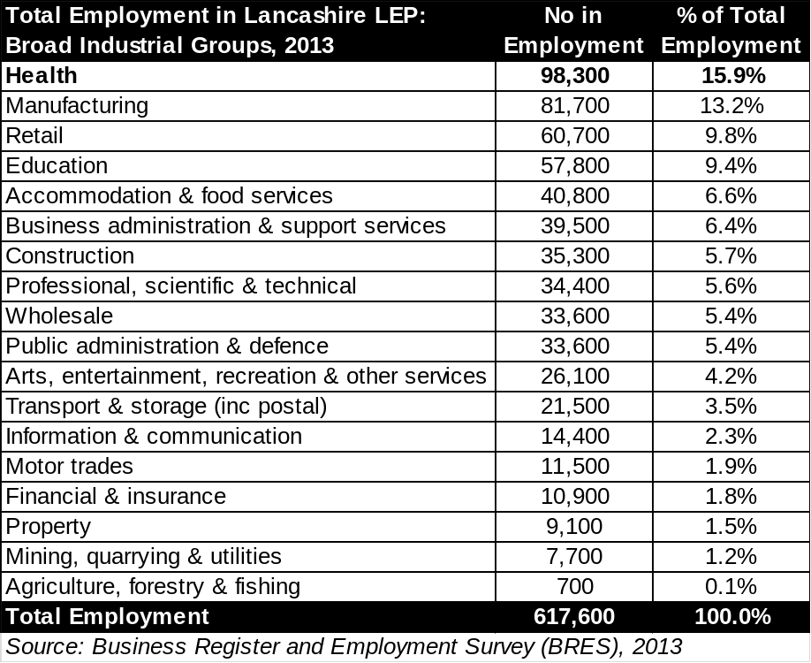
  - In the Lancashire LEP area, Preston, Blackburn with Darwen and Blackpool local authorities have the highest levels of employment in the health & social care sector. The greatest concentration of employment is in Preston, which accounts for 15,500 jobs and 15.8% of all employment in Lancashire LEP’s health & social care sector. Blackburn with Darwen contains the second highest level of employment in the health & social care sector across the Lancashire LEP area accounting for 12,800 jobs and 13.0% of all employment in the sector. Blackpool has the third highest level of employment in the sector, representing 11,300 jobs and 11.5% of all employment in the sector across the Lancashire LEP area (see Figure 2).
Figure 2: Heath & Social Care Employment by District, 2013
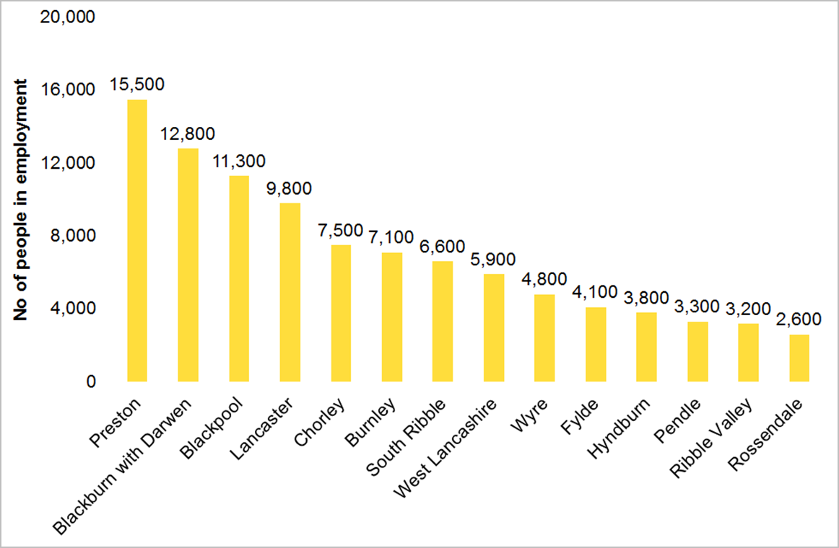
Source: Business Register and Employment Survey
  - As explained above, Preston has the highest concentration of health & social care employment across the Lancashire LEP area, containing 15,500 jobs and representing 15.8% of all employment in the sector across the Lancashire LEP area. However, Preston also experienced the greatest decline in employment in the sector in the period 2010-2013 across all Lancashire LEP local authorities. Its employment in the sector declined from 18,300 to 15,500, a decrease of 2,800 jobs (15.3%). Consequently, Preston’s proportional share of all health & social care sector employment across the Lancashire LEP area decreased from 19.1% to 15.8%, a decline of 3.3%.
  - In contrast, Blackburn with Darwen experienced the greatest absolute growth of employment in the health & social care sector across all Lancashire LEP local authorities. During the period 2010-13, employment in health & social care in Blackburn with Darwen increased from 10,700 in 2010 to 12,800 in 2013, representing an increase of 2,100 jobs (19.6%). The largest proportional increase in employment in the sector during the period 2010-14 occurred in Burnley. Health & social care employment in Burnley increased from 5,700 in 2010 to 7,100 in 2014, representing a rise of 24.6% and 1,400 jobs.
  - At a TTWA area level, in Lancashire only the Preston TTWA experience a decline in health & social care employment from 2010-13. It fell by 5.3%, representing 1,800 fewer jobs (see Figure 3).

Figure 3: Health & Social Care Employment Change by District & TTWA, 2010-13
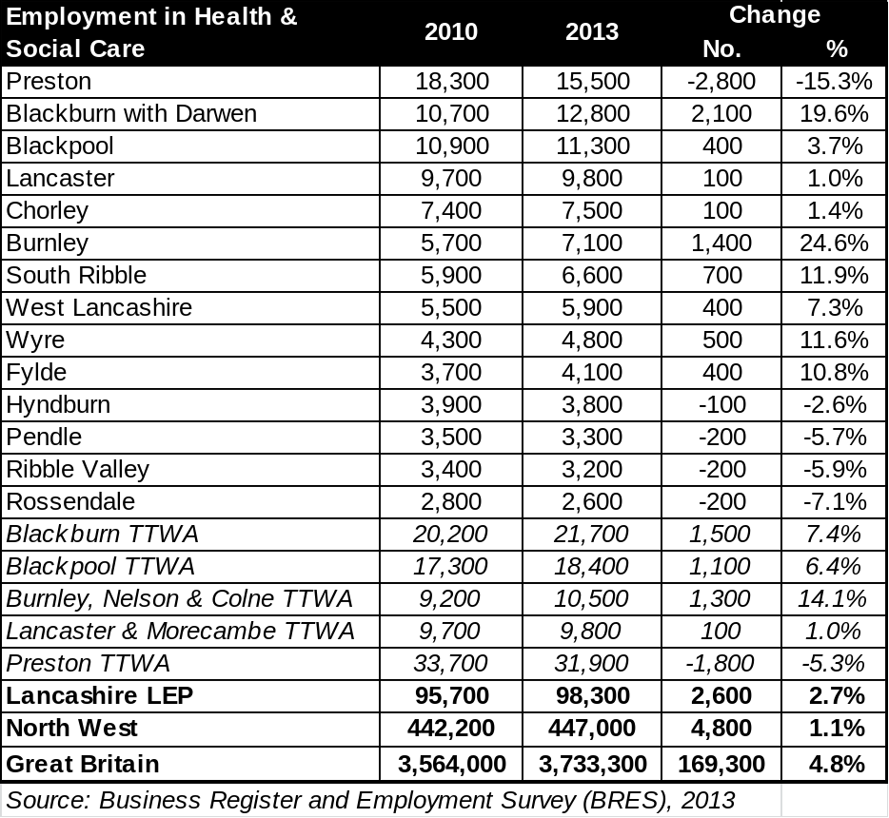
  - With regard to health & social care sub-sectors, the largest absolute increase in employment occurred in ‘Hospital activities’ which grew from 34,300 in 2010 to 40,100 in 2013 in Lancashire, representing an increase of 5,800 (16.9%). ‘Social work activities without accommodation for the elderly and disabled’ experienced the largest proportional increase in employment of 38.6%; employment grew from 8,300 in 2010 to 11,500 in 2013, a rise of 3,200. ‘Other human health activities’ saw the greatest proportional decrease in employment, falling by 42.6%; employment decreased from 10,100 in 2010 to 5,800 in 2013, a fall of 4,300. The sub-sector of ‘Other social work activities without accommodation not elsewhere classified’ saw its employment decrease from 14,600 in 2010 to 11,100 in 2013, representing a decrease of 3,500 jobs (24.0%) and likely to be due to cuts in funding at day centres, for example. Figure 4 shows changes across all health & social care sectors in Lancashire LEP from 2010-13.

Figure 4: Health & Social Care Employment Change by Sub-Sector in Lancashire, 2010-13
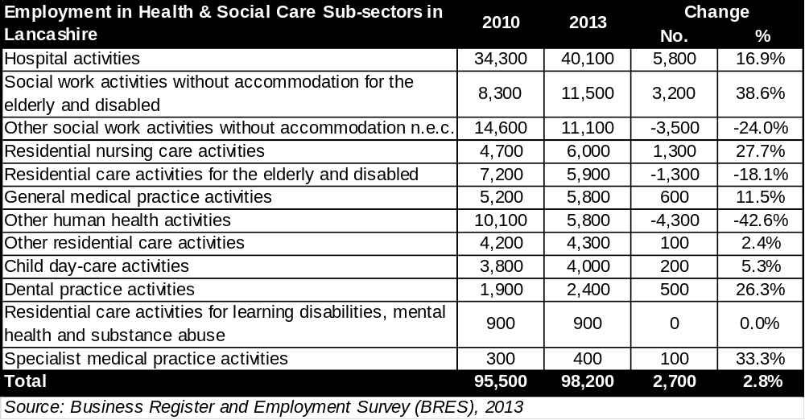
  - The number of employees in the Lancashire LEP area employed in research and development (R&D) in the health & social care sector was approximately 800 in 2013 according to the Business Register and Employment Survey (BRES). This represents a substantial decrease from 2010 when approximately 1,300 were employed in R&D. It should be noted that almost all R&D employment is in SIC code 7219: Other research and experimental development on natural sciences and engineering. Data for SIC codes 7211: Research and experimental development on biotechnology and 7220: Research and experimental development on social sciences and humanities is too limited to be representative.
Location Quotients
  - Location Quotients “can be interpreted as a local measure of geographical concentration of industries” (Office for National Statistics). The location quotient (LQ) of an industry is an analytical statistic which measures an area’s industrial specialisation relative to a benchmark (in this case Great Britain). LQs are calculated by comparing the industry’s share of employment in Lancashire with its share of GB employment. For example, if a sector accounts for 10% of all jobs in an area, but only 5% of all GB jobs, the area’s LQ for that sector is 2. This means jobs in this particular sector are two times more concentrated in that area than average.
  - The analysis conveys that the sub-sectors of ‘Social work activities without accommodation for the elderly and disabled’, ‘Residential nursing care activities’, and ‘Hospital activities’ respectively account for a larger share of employee jobs in the Lancashire LEP area in comparison with the national level. Indeed, the sub-sector of ‘Social work activities without accommodation for the elderly and disabled’ is nearly two times more concentrated than the national average (see Figure 5).
Figure 5: Health & Social Care Location Quotients in Lancashire
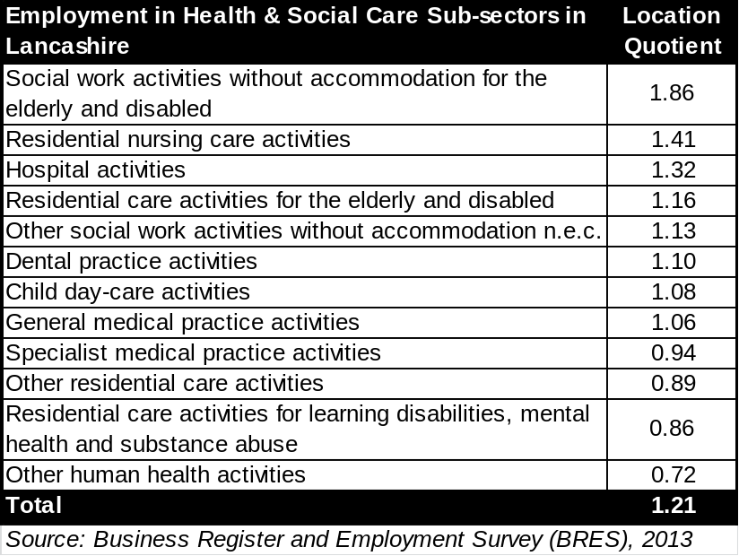
  - Appendix B provides LQ information down to a local authority level and TTWA. The main points to note are:
- District level: The highest LQ for any sub-sector is in Burnley – 4.63 for “Social work activities without accommodation for the elderly and disabled”. This is closely followed by Chorley, which has an LQ of 4.47 – also for “Social work activities without accommodation for the elderly and disabled”. Other LQs to highlight at a district level include: 3.46 in Pendle for “Residential care activities for learning disabilities, mental health and substance abuse”; 3.30 in Rossendale for “Residential nursing care activities”; and 3.14 in Ribble Valley for “Residential care activities for learning disabilities, mental health and substance abuse”.

- Travel to Work Areas: The highest LQ for any sub-sector is in Burnley, Nelson & Colne – 3.08 for “Social work activities without accommodation for the elderly and disabled”. This is followed by Lancaster & Morecambe, which has an LQ of 1.95 – for “Residential care activities for the elderly & disabled”.

Business Base
  - The Inter-Departmental Business Register (IDBR) shows there were just over 55,000 businesses trading in the Lancashire LEP area in 2014. There are 3,900 businesses operating in the health & social care sector in the Lancashire LEP area, representing 7.1% of the entire business base. It is the fourth largest business sector in the Lancashire LEP area. The largest business sectors are retail; professional, scientific & technical and construction, cumulatively accounting for 18,770 businesses or more than one third (34.1%) of all businesses in the Lancashire LEP area (see Figure 6).
Figure 6: Businesses by Broad Sector in Lancashire, 2014
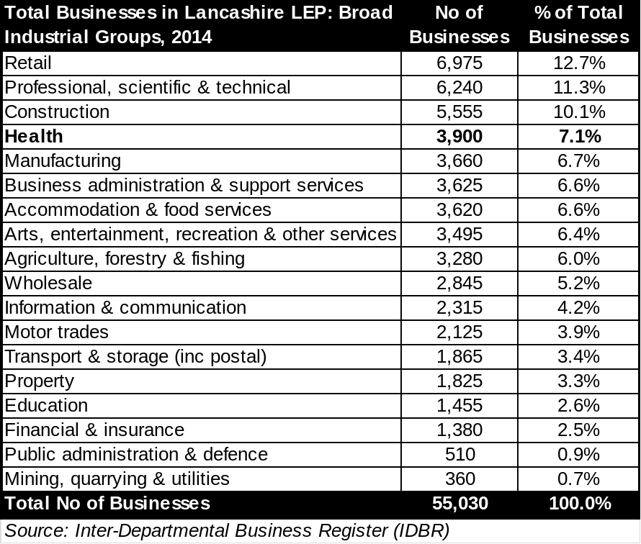
  - The number of businesses in the health & social care sector increased from 3,555 in 2010 to 3,900 in 2014, representing an increase of 345 (9.7%) businesses over the period (see Figure 7). Within the sector ‘Human health activities’’ businesses account for the majority of these companies; increasing from 1,365 in 2010 to 1,705 in 2014, representing an increase of 340 (24.9%). These include: hospital activities, general and specialist medical practice and dental practice activities.
Figure 7: Health & Social Care Business Change in Lancashire, 2010-14
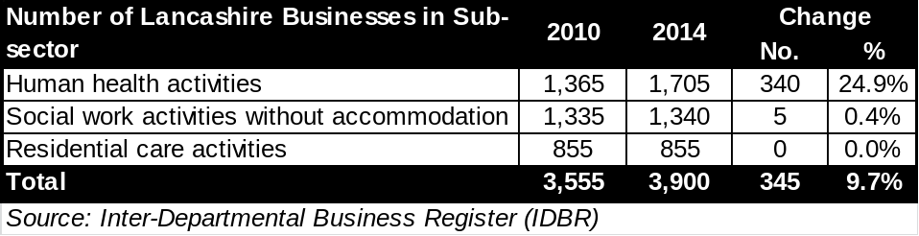
  - With regard to local authority proportions, the greatest proportion of health & social care businesses are located in Preston, which is home to 445 businesses and 11.4% of all health and social care businesses in the Lancashire LEP area (see Figure 8). Blackburn with Darwen has the second highest number of health and social care businesses only marginally lower than Preston (440, 11.3%); Blackpool (400, 10.2%) and Lancaster (380, 9.7%) have the third and fourth highest number of businesses. Ribble Valley contains the lowest number of health & social care businesses (145, 3.7%).
Figure 8: Health & Social Care Business by District, 2014
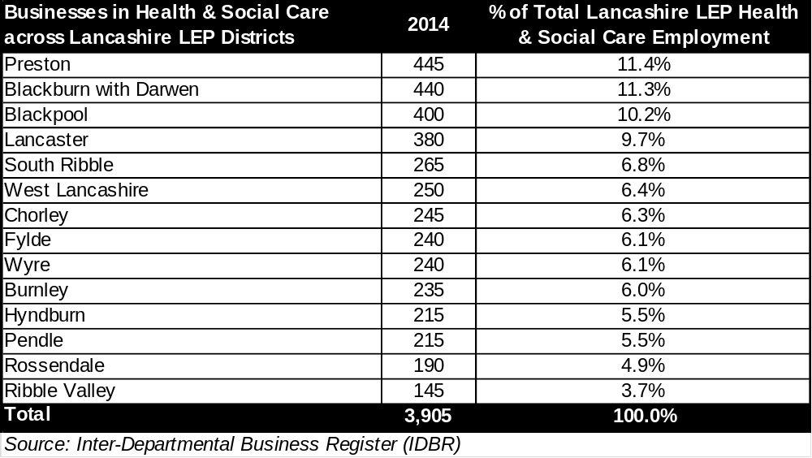
  - Health & social care businesses in Lancashire tend to be small with more than half (55.3%) employing 9 or fewer people; 36.8% of businesses employ 10-49 people and 7.4% (290) of businesses employ 50-249 people (see Figure 9). There are very few large businesses with 250 or more employees in the health and social care sector; they represent only 0.5% (20) of all health & social care businesses in Lancashire LEP. However, on average health & social care businesses in Lancashire have more employees than typical for all businesses in Lancashire (81.5% of all businesses in Lancashire employ 9 or fewer people; 15.1% of all businesses employ 10-49 people; 3% of all businesses employ 50-249 people; 0.4% of all businesses employ 250 or more people).
Figure 9: Health & Social Care Businesses by Size in Lancashire, 2014
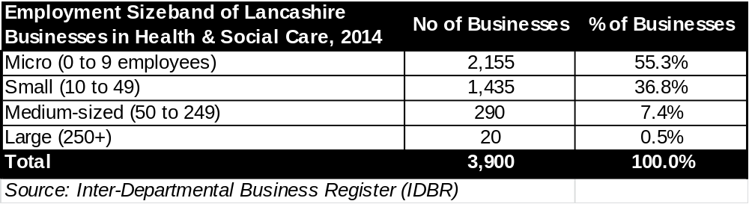
Key Business Sub-Sectors
  - The largest numbers of businesses are in the ‘Other social work activities without accommodation not elsewhere classified’ sub-sector accounting for 640 businesses in 2014; declining by 60 (8.6%) from 2010, although they represent 16.4% of all Health and Social Care businesses in the LEP area. The second largest business sub-sector is ‘Other human health activities’ representing 590 businesses in 2014, increasing by 85 (16.8%) since 2010; they account for 15.1% of the health & social care business base. The third biggest health & social care sub-sector is ‘General medical practice activities’ accounting for 460 businesses in 2014, having increased by 50 (12.2%) since 2010; they represent 11.8% of all Health & Social Care businesses (see Figure 10).
  - The greatest absolute increase in businesses was in the ‘Hospital activities’ sub-sector, in which the number of businesses increased from 165 in 2010 to 300 in 2014, representing a rise of 135 (81.8%). The substantial rise in hospital activities is likely to be due to NHS commissioners now being able to commission 'any qualified provider' to deliver services, which is leading to more niche providers who deliver hospital services. The ‘Hospital activities’ sub-sector accounts for 7.7% of all businesses in Lancashire LEP’s health & social care sector.
Figure 10: Health & Social Care Business Change in Lancashire, 2010-14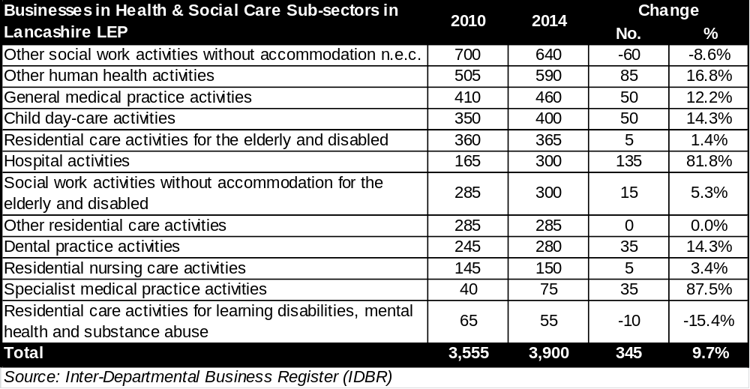
  - There are approximately 50 businesses active in research and development (R&D) across the health & social care sector in the Lancashire LEP area according to the Inter-Departmental Business Register (2014). There has been no significant change in the number of active R&D health & social care sector businesses in the period 2010-2014. The following SIC Codes contribute to the research and development category: 5 businesses in 7211: Research and experimental development on biotechnology; 45 businesses in 7219: Other research and experimental development on natural sciences and engineering; and 0 businesses in 7220: Research and experimental development on social sciences and humanities. However, please note that this data is subject to Office for National Statistics rounding and suppression stipulations.
Forecasts
  - The forecasts below have been prepared by Oxford Economics. Their forecasting methodology is not consistent with data utilised elsewhere in this report derived from the Business Register and Employment Survey (BRES), therefore the different datasets cannot be directly compared.
  - Total Employment across the Lancashire LEP region is expected to increase from 729,000 in 2014 to 765,200 by 2024; this represents an increase of 36,200 (5.0%). Employment is expected to increase the most in the Administrative and support services activities sector by 10,100 (21.4%) over the period 2014-2024. Construction employment is projected to increase by 10,000 (18.5%) over the same period, it is expected to be the second largest growth sector. Conversely, manufacturing is projected to experience the greatest absolute decline over the forecast period, losing 9,100 (10.4%) of its employment (see Figure 11)
Figure 11: Employment Forecasts- Broad Industrial Groups, 2014-24
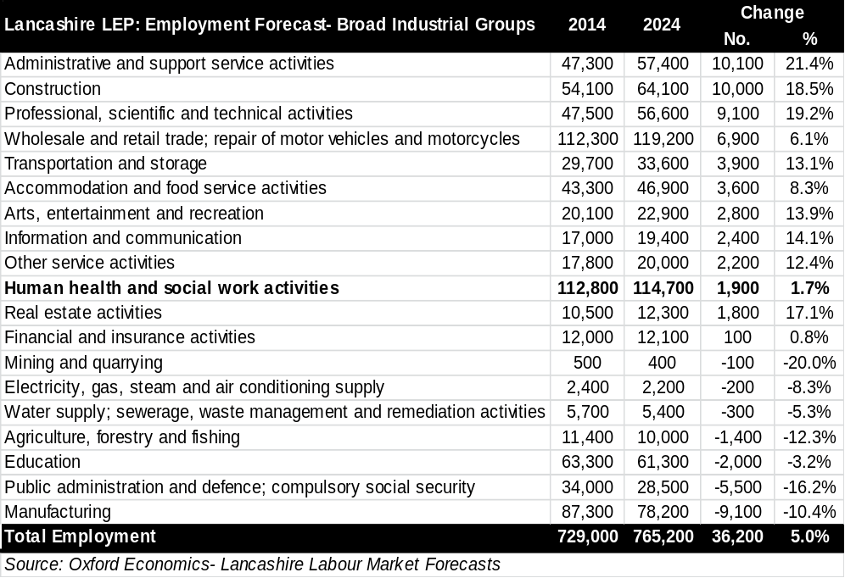
  - Employment in Lancashire LEP region’s health & social care sector is forecast to grow by 1,900 (1.7%) in the period 2014-24 (see Figure 12). Lancashire LEP’s employment in the health & social care sector is expected to increase slightly more (0.1%) than the North West average of 1.6%, however this is substantially below the national predicted growth of 2.9%. Total employment in the area is to expected grow by 5.0% over the same period, meaning growth of employment in the health & social care sector is expected to be lower than overall employment growth. The Social work activities sub-sector is predicted to experience the largest growth out of the three Health & Social Care sub-sectors i.e. an increase of 1,100 (3.3%) employees.
Figure 12: Health & Social Care Employment Forecasts, 2014-24
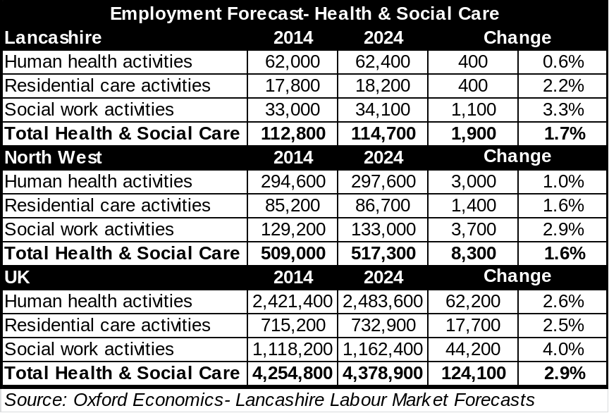
  - With regard to Lancashire LEP area’s constituent local authority districts, Lancaster is predicted to experience the largest increase in employment in the health & social care sector over the period 2014-24 throughout Lancashire. Lancaster’s employment is expected to grow from 11,300 to 12,000; this represents an increase of 700 (6.2%). Chorley and West Lancashire are predicted to experience employment growth in the health & social care sector of 5.7% (500) and 4.5% (300) respectively. Meanwhile, employment in the sector in the districts of Burnley, Pendle, Preston and South Ribble is expected to remain constant. However, Ribble Valley and Blackpool are predicted to experience modest decline in health & social care employment (see Figure 13).
Figure 13: Employment Forecast for Lancashire LEP Districts: Health & Social Care- Change 2014-2024
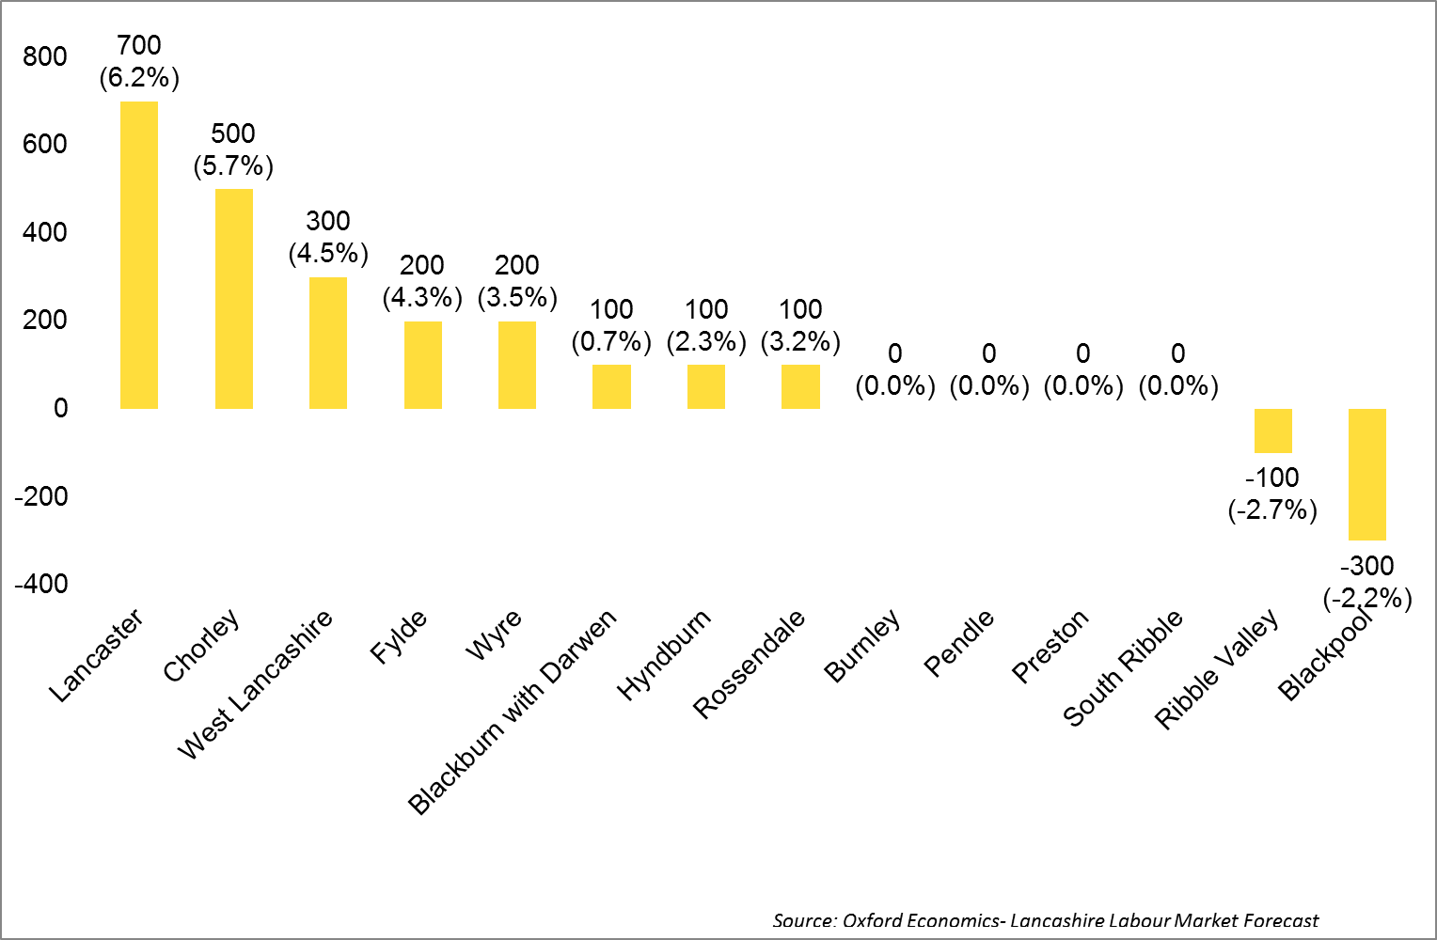
Source: Business Register and Employment Survey
Demographic Change
  - Lancashire LEP’s total population was 1.47million in 2012 (see Figure 14). This is expected to increase to just over 1.5million by 2024, representing an increase of 41,000 (2.8%). It should be noted that Lancashire LEP’s population is ageing. Lancashire LEP’s population aged 65 and over was just under 270,000 in 2012. This is projected to increase to just over 330,000 by 2024, representing an increase of around 62,000 (23.0%). Over the period 2012-2024, the North West’s population aged 65 and over is expected to increase by 24.2%; England’s population aged over 65 is expected to increase by 27.6%.
Figure 14: Population Projections for Lancashire, 2012-24
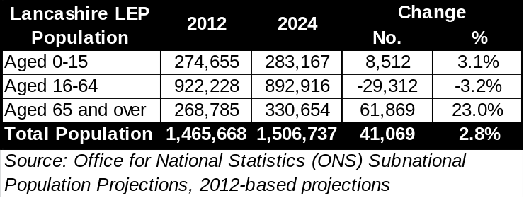
  - Figures 15-28 show population projections for each district in Lancashire LEP from 2014-24. There are a number of variations at a local authority level, notably:
- With the exception of Blackpool and Burnley where numbers are expected to remain broadly the same, all districts in Lancashire LEP are projected to see an increase in their total population from 2012-24. In absolute and relative terms, Chorley (9.1%, or 10,000 additional people) is estimated to see the largest rise.

- Chorley and Rossendale are projected to see the highest percentage increases in people aged 65 and over from 2012-24, with increases of 35.5% and 31.9% respectively.

- Chorley is the only district projected to see an increase in its working age population (16-64), with an estimated rise of 2.1% (1,500 additional people).

- Rossendale is projected to see the largest percentage increase in the number of people aged 0-15 (8.5%, or 1,100 additional people).

Figure 15: Population Projections for Blackburn with Darwen, 2014-24
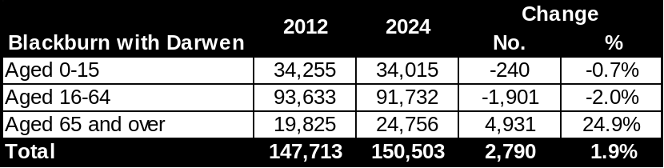
Figure 16: Population Projections for Blackpool, 2014-24
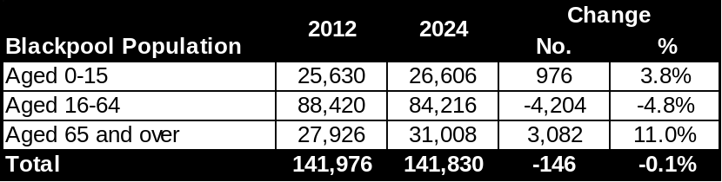
Figure 17: Population Projections for Burnley, 2014-24
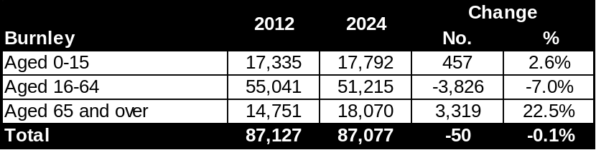
Figure 18: Population Projections for Chorley, 2014-24
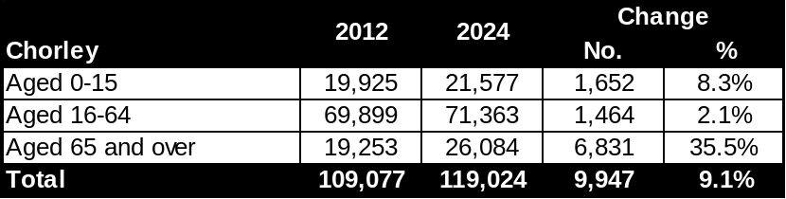
Figure 19: Population Projections for Fylde, 2014-24
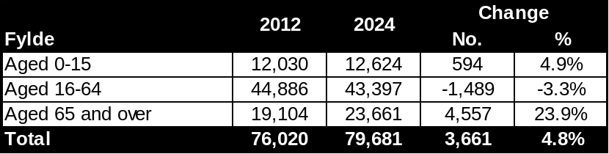
Figure 20: Population Projections for Hyndburn, 2014-24
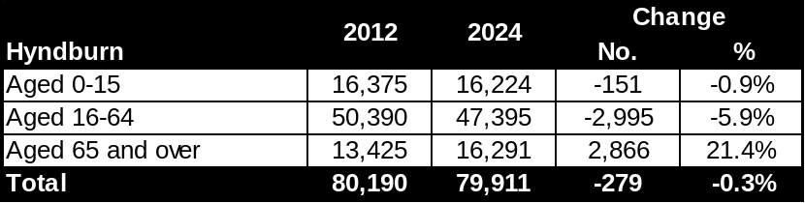
Figure 21: Population Projections for Lancaster, 2014-24
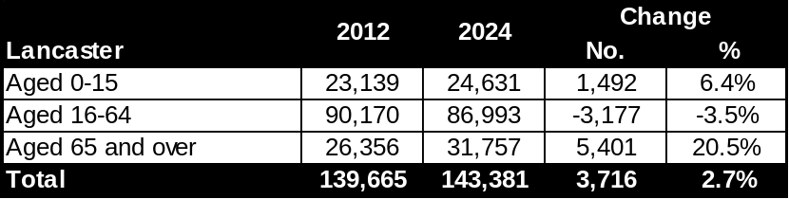
Figure 22: Population Projections for Pendle, 2014-24
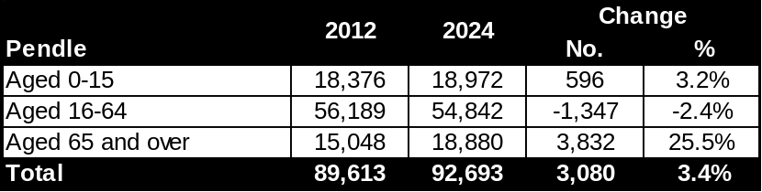
Figure 23: Population Projections for Preston, 2014-24
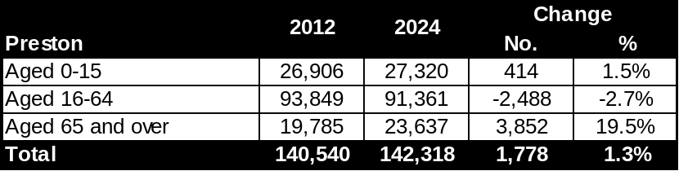
Figure 24: Population Projections for Ribble Valley, 2014-24
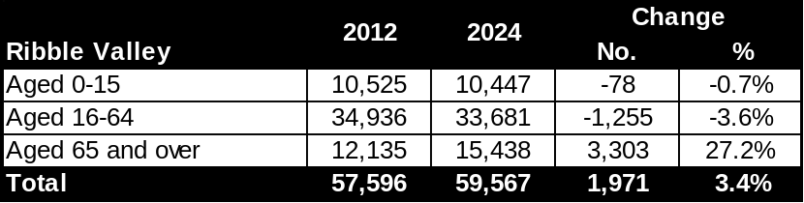
Figure 25: Population Projections for Rossendale, 2014-24
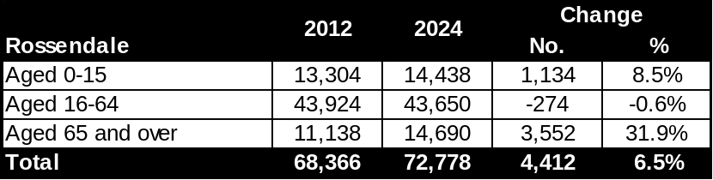
Figure 26: Population Projections for South Ribble, 2014-24
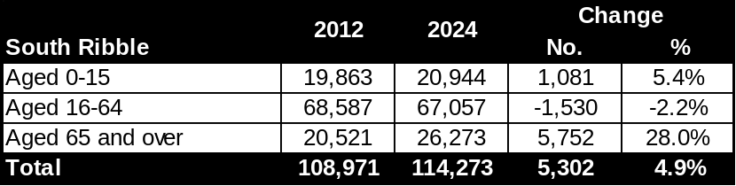
Figure 27: Population Projections for West Lancashire, 2014-24
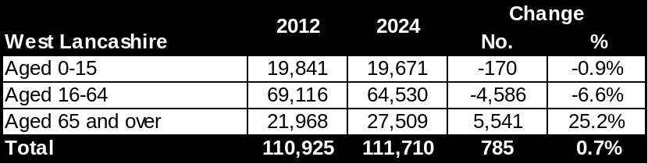
Figure 28: Population Projections for Wyre, 2014-24
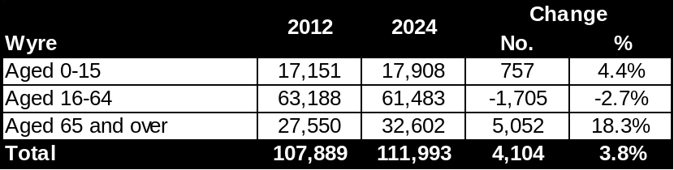
Source for Figures 15-28: ONS subnational population projections (2012-based)
Workforce Profile
  - There are a number of different sources which allow for the analysis of the workforce in the health & social care sector, including the 2011 Census and quarterly Labour Force Survey (LFS). In addition, Skills for Care holds detailed figures for the social care sub-sector in or National Minimum Dataset for Social Care (NMDS-SC). Each of these three datasets is discussed below.
2011 Census
  - The Census provides data on the qualifications of the workplace population aged 16-74 working in “human health & social work activities”. Analysis of the figures shows a substantial proportion of people with higher level skills. In particular, 44.0% of the workplace population in Lancashire in the sector have a level 4 or higher qualification (degree, BTEC etc.). This is well above the average for the whole of the workplace population (30.0%), and a similar trend is evident at a national level (see Figure 29).
Figure 29: Highest level of qualification of workplace population aged 16-74 working in the human health & social work activities sector
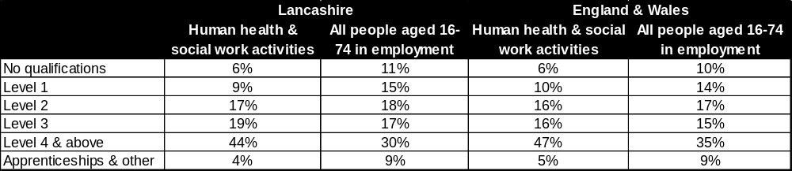Source: 2011 Census
  - The Census also provides information on the occupation profile of the workplace population. While it isn’t possible to get figures specifically on health & social care, the data are available for the wider publication administration, education & health sector. Figure 30 provides the data for Lancashire and England & Wales – showing the relatively high proportion of the workplace population in “caring, leisure & other service” roles (26% in Lancashire, well above the LEP average of 11% for all sectors). Professional occupations also account for a high proportion of the workplace population in the sector – 31%, compared to 16% for all workers in Lancashire. Similar trends are also evident at a national level.
Figure 30: Occupation profile of workplace population aged 16-74 working in public administration, education & health
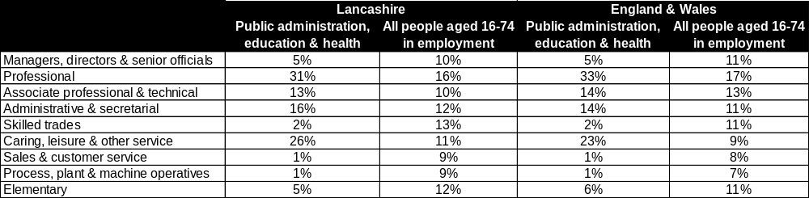 Source: 2011 Census
  - Figure 31 shows the age profile of the workplace population, again for the wider public administration, education & health sector in both Lancashire and England & Wales. It can be seen that there are fewer young people (those aged 24 & under) in the sector– 9% in Lancashire and 8% in England & Wales, compared to an overall average of 13% in both areas. In addition, 54.0% of the sector’s workplace population in Lancashire is aged 35-44, above the average for all industries of 49.0% – a trend repeated nationally.
Figure 31: Age profile of workplace population aged 16-74 working in public administration, education & health
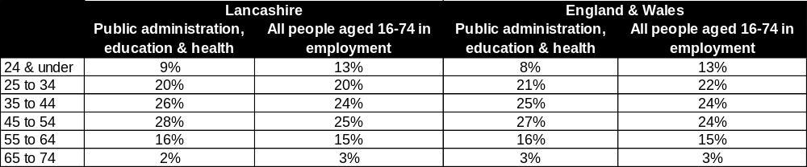 Source: 2011 Census
Quarterly Labour Force Survey
  - Data from the quarterly Labour Force Survey (LFS) also shows that in the North West, there is a higher percentage of workers aged 50 years or older in the health and social care sector, compared with the average across all sectors (30% compared to 28.4% respectively). The health and social care sector also has a lower proportion of workers under 30 than the all-sector average – 20.9% compared to 24.7%. The age groups where the health and social care sectors surpass the sector average in the North West are between the ages of 30 and 55, with 62.8% of the total health and social care workforce falling into this category, compared to 58.6% in other sectors.
National Minimum Dataset for Social Care
  - The (NMDS-SC) on the social care sub-sector is available via Skills for Care (SfC). This provides information on various workforce characteristics, including the age profile of people – as highlighted in Figure 32. This shows that around one third (33.1%) of the social care workforce in Lancashire recorded in the NMDS-SC) is aged 34 or under, slightly higher than the national average of 30.9%. In addition, one in five member of the workforce are aged 55 and over in Lancashire.
Figure 32: Age Profile of the Social Care Workforce in Lancashire
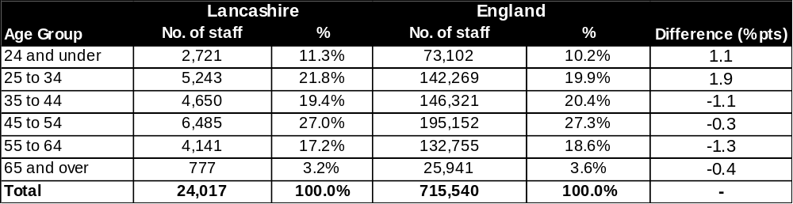Source: Skills for Care National Minimum Dataset
  - The SfC dataset also gives information on the nationality of the social care workforce recorded in the NMDS-SC. As shown in Figure 33, just over 70% are British and this is marginally higher than the national average of 68%.
Figure 33: Nationality of the Social Care Workforce in Lancashire
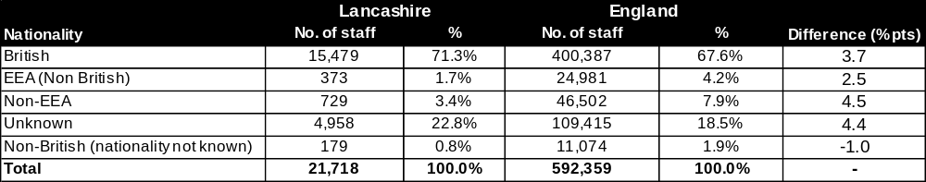Source: Skills for Care National Minimum Dataset
  - According to the SfC dataset, around one quarter of the social care workforce recorded in the NMDS-SC hold no qualifications, well below the national average of almost one third. More than half (55.8%) have a Level 2, 3 or 4 qualification, in line with national trends (see Figure 34).
Figure 34: Qualifications of the Social Care Workforce in Lancashire
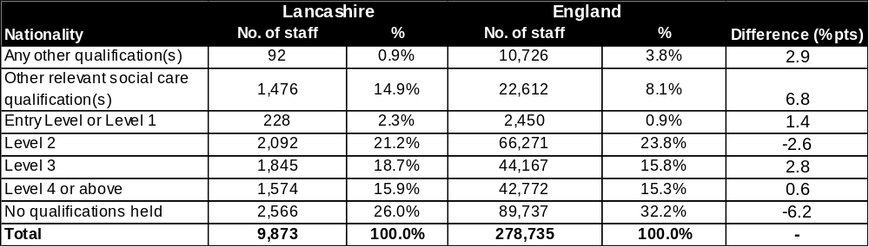Source: Skills for Care National Minimum Dataset
  - Of the people recorded in the NMDS-SC in Lancashire, the average annual salary is around £16,500. The national average for the sector is slightly higher at £17,000. According to the Annual Survey of Hours and Earnings published by the Office for National Statistics, the gross median annual salary for full time workers in Lancashire in 2014 was far higher at £24,400.
Higher Education Students
  - Data sourced from the Higher Education Statistics Agency (HESA) show that in 2013/14, there were just over 16,500 students (undergraduate and postgraduate) studying health & social care-related subjects at Higher Education Institutions in Lancashire. The University of Central Lancashire has the highest number of students at just over 9,000, of which 5,000 are studying “subjects allied to medicine”. This includes almost 3,000 nursing students, 550 pharmacology, toxicology & pharmacy students and just over 400 students studying “complementary medicines, therapies & well-being”.
  - Edge Hill University has the second highest number of HE students in health & social care-related subjects at almost 5,800, of which 3,100 are studying nursing (included within “subjects allied to medicine”). Figure 35 provides further detail on HE student numbers in Lancashire HEIs.
Figure 35: HE Students in Lancashire by Institution, 2013/14
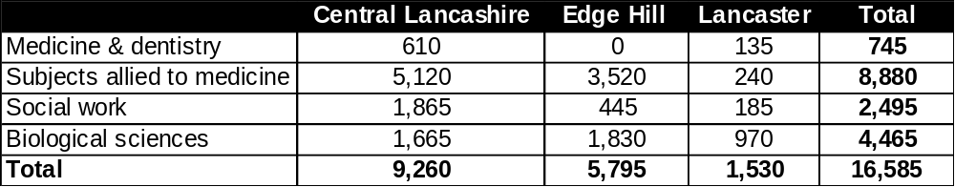
Source: HESA
  - Figure 36 provides information on HE student numbers across the North West in medicine & dentistry. As can be seen, the Universities of Manchester and Liverpool dominate in terms of absolute numbers – accounting for 6,500 of the 7,500 total.
Figure 36: Medicine & Dentistry HE Students in the North West, 2013/4
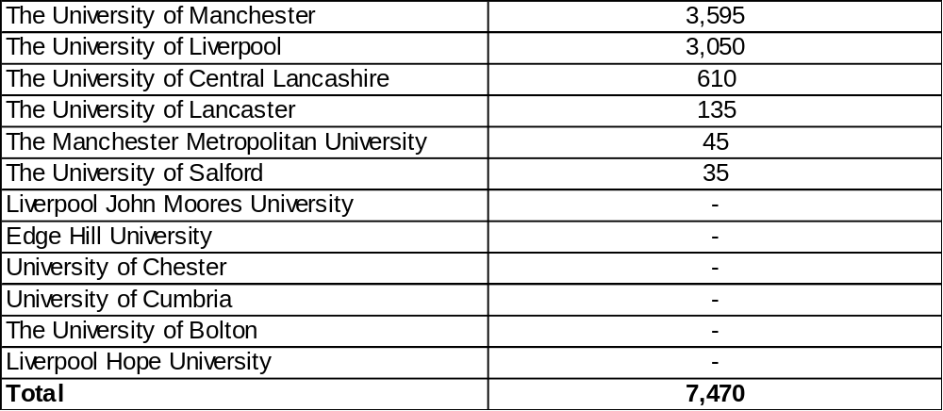
Source: HESA
  - Figure 37 provides information on HE student numbers across the North West in “subjects allied to medicine”. Central Lancashire has the highest number of students, followed by Salford and Manchester. In total, there are more than 32,000 students and around 18,000 of these are studying nursing.
Figure 37: Subjects allied to medicine HE Students in the North West, 2013/4
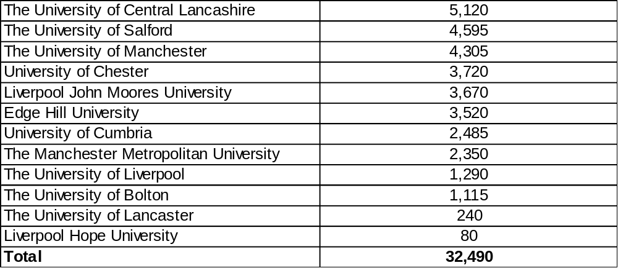
Source: HESA
  - Figure 38 provides information on HE student numbers across the North West in social work. Central Lancashire accounts for almost 1,900 of the 6,000 total – the highest absolute figure of any North West HEI.
Figure 38: Social Work HE Students in the North West, 2013/4
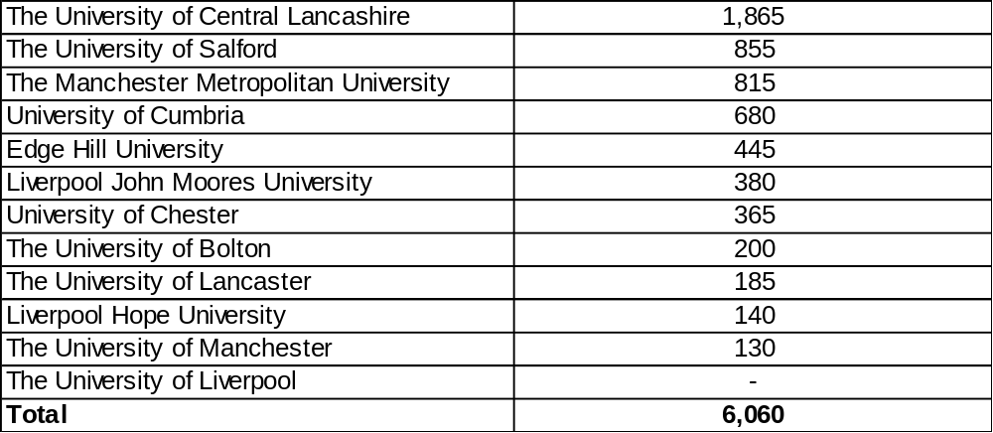
Source: HESA
  - Figure 39 provides information on HE student numbers across the North West in biological sciences, which total just over 20,000. Of this total, there are around 7,500 psychology students (1,000 are at Central Lancashire, the highest number for any North West HEI) and a further 5,000 are studying sport & exercise science.
Figure 39: Biological sciences HE Students in the North West, 2013/4
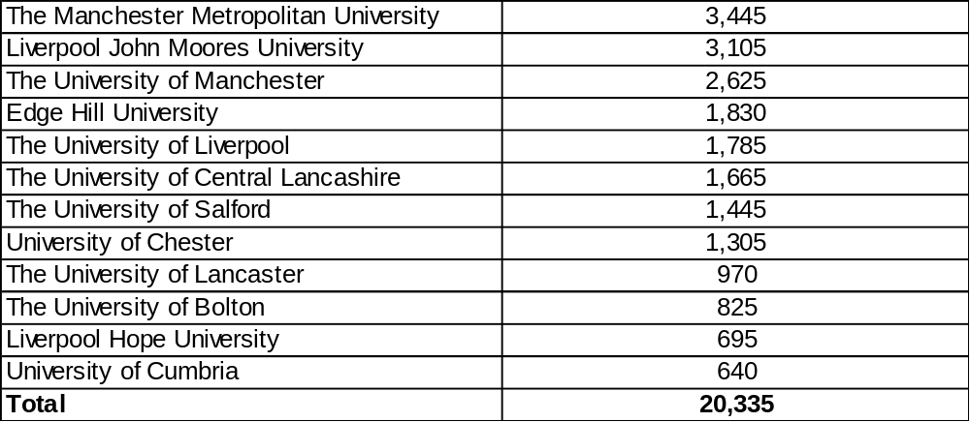
Source: HESA
Data Cube
  - Information from the LEP Data Cube provides historic learning aim starts and achievement data funded by the Skills Funding Agency (SFA) and Education Funding Agency (EFA) for Lancashire, for 2012/13 & 2013/14. Data are available on a learner and delivery basis. Learner location, based on the learners’ resident postcode, presents the data in terms of where individuals live. However, this may not be the same local authority location in which they undertake their study or work. Delivery location postcode data relates to training being undertaken within an area, though a proportion of the learners may be resident outside of the delivery location.
  - All Data Cube analysis presented below focuses on starts and achievements within the “Health, Public Services & Care” sector, which includes the following sub-sectors:
- Medicine and Dentistry
- Nursing and Subjects and Vocations Allied to Medicine
- Health and Social Care
- Public Services
- Child Development and Well Being
Data Cube Learner Analysis
  - The learner Data Cube shows that the number of health, public services & care sector starts in Lancashire was just over 27,500 in 2013/14. This was down slightly on the 30,000 recorded in 2012/13. At a sub-sector level, the largest number of starts was in health & social care at just over 20,000. Figures 40 and 41 provide sub-sector starts in the entire sector in Lancashire for 2012/13 and 2013/14 respectively. Both figures highlight that the highest number of starts were made by people aged 25 and over.
Figure 40: Health, Public Services & Care Sector Starts in Lancashire by Sub-Sector, 2012/13
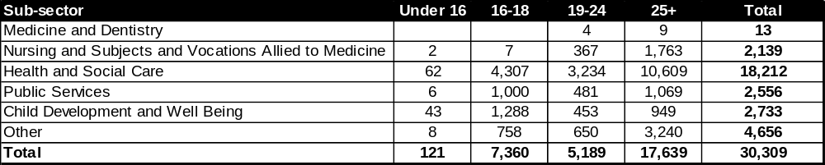
Source: LEP Data Cube

Figure 41: Health, Public Services & Care Sector Starts in Lancashire by Sub-Sector, 2013/14
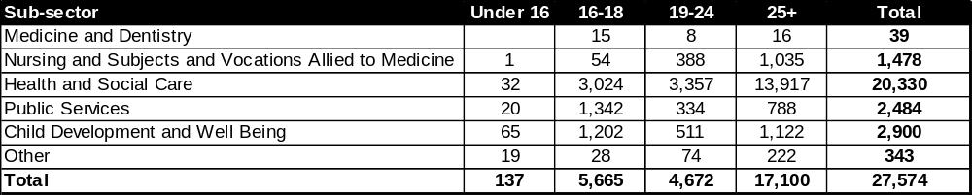
Source: LEP Data Cube

  - Looking at the different levels of starts within the sector, in 2013/14 the highest number in Lancashire were at Level 2 (around 10,000), followed by Level 1 at just under 6,500 (see Figure 42).
Figure 42: Health, Public Services & Care Sector Starts in Lancashire by Notional NVQ Level, 2013/14
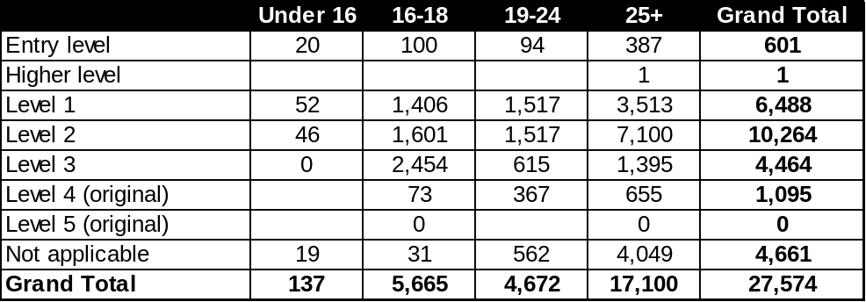
Source: LEP Data Cube

  - Lancashire County Council accounted for the most health, public services & care starts in the LEP area in 2013/14 at almost 4,000. This was followed by Blackburn College and Accrington & Rossendale College (both at 2,400). Figure 43 shows the top 10 provides in Lancashire LEP and combined, they accounted for almost 70% of all starts in the sector in 2013/14.
Figure 43: Health, Public Services & Care Sector Starts in Lancashire, 2013/14 – 10 largest providers
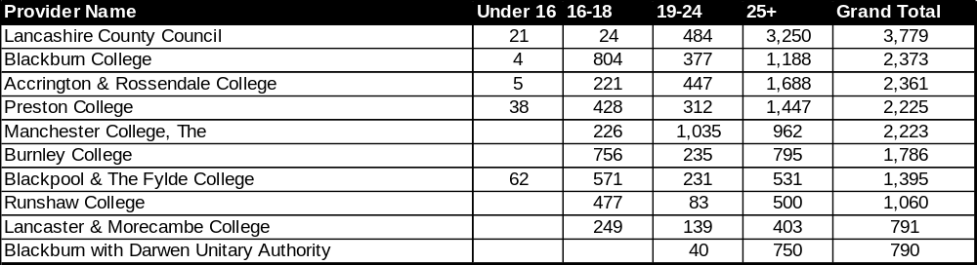
Source: LEP Data Cube

  - Turning to look at achievements, there were just over 24,000 within Lancashire in 2013/14, down from around 37,000 in 2012/13. In line with the starts data, health & social care accounted for the highest share of achievements at approximately 18,000. This represents an increase on the 2012/13 total for the sub-sector of 15,500. Figures 44 and 45 provide sub-sector achievements in the entire sector in Lancashire for 2012/13 and 2013/14 respectively.

Figure 44: Health, Public Services & Care Sector Achievements in Lancashire by Sub-Sector, 2012/13
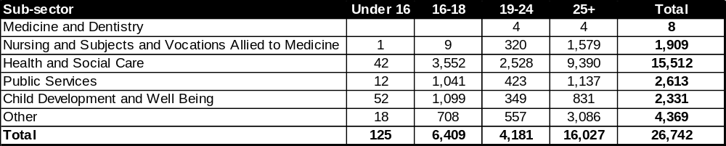
Source: LEP Data Cube

Figure 45: Health, Public Services & Care Sector Achievements in Lancashire by Sub-Sector, 2013/14
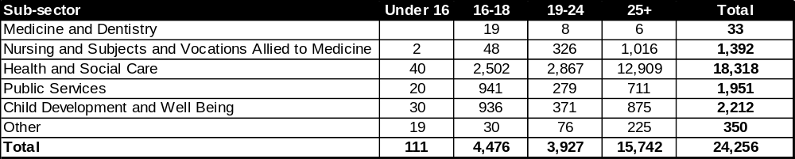
Source: LEP Data Cube

  - Looking at the different levels of achievements within the sector, in 2013/14 the highest number in Lancashire were at Level 2 (around 9,000), followed by Level 1 at just under 5,800 (see Figure 46).
Figure 46: Health, Public Services & Care Sector Achievements in Lancashire by Notional NVQ Level, 2013/14
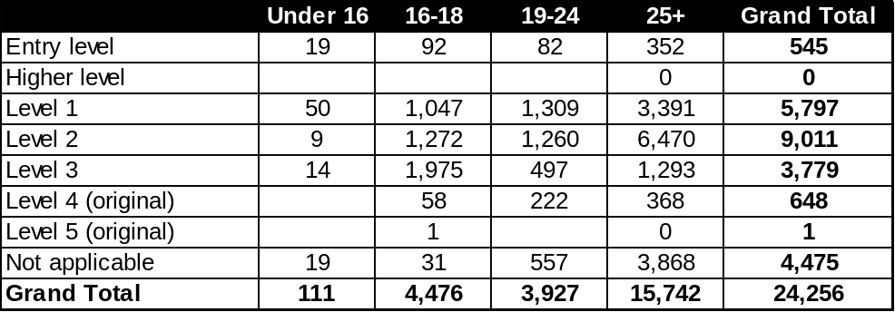
Source: LEP Data Cube

  - Lancashire County Council accounted for the most health, public services & care achievements in the LEP area in 2013/14 at around 3,500. This was followed by Accrington & Rossendale College (2,200) and Blackburn College (2,000). Figure 47 shows the top 10 providers in Lancashire LEP and combined, they accounted for nearly 70% of all starts in the sector in 2013/14.
Figure 47: Health, Public Services & Care Sector Achievements in Lancashire, 2013/14 – 10 largest providers
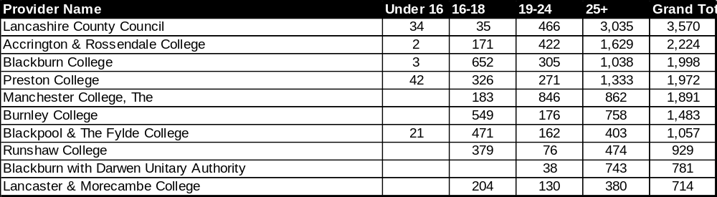
Source: LEP Data Cube

Data Cube Delivery Analysis
  - The delivery Data Cube shows that the number of health, public services & care sector starts in Lancashire was just under 26,000 in 2013/14. This was down slightly on the circa 28,000 recorded in 2012/13. At a sub-sector level, the largest number of starts was in health & social care at just under 19,000. Figures 48 and 49 provide sub-sector starts in the entire sector in Lancashire for 2012/13 and 2013/14 respectively. Both figures highlight that the highest number of starts were made by people aged 25 and over.
Figure 48: Health, Public Services & Care Sector Starts in Lancashire by Sub-Sector, 2012/13
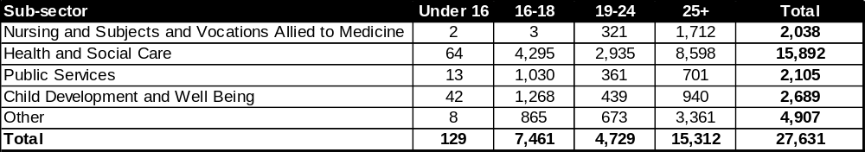
Source: LEP Data Cube

Figure 49: Health, Public Services & Care Sector Starts in Lancashire by Sub-Sector, 2013/14
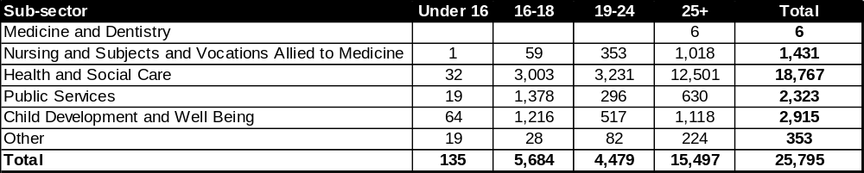
Source: LEP Data Cube

  - In terms of the different levels of starts within the sector, in 2013/14 the highest number in Lancashire were at Level 2 (around 7,800), followed by Level 1 at 7,000 (see Figure 50).
Figure 50: Health, Public Services & Care Sector Starts in Lancashire by Notional NVQ Level, 2013/14
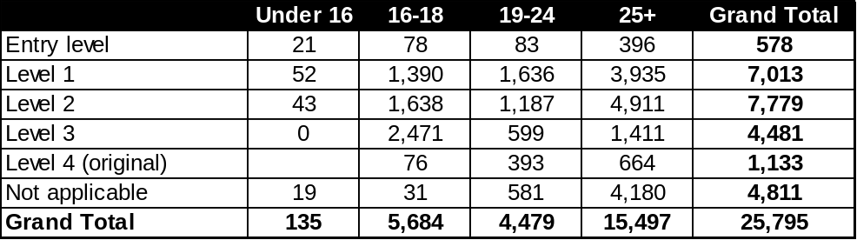
Source: LEP Data Cube

  - Lancashire County Council accounted for the most health, public services & care starts in the LEP area in 2013/14 at 3,900. This was followed by Preston College at 2,600. Figure 51 shows the top 10 provides in Lancashire LEP, which in total accounted for 80% of all starts in the sector in 2013/14.

Figure 51: Health, Public Services & Care Sector Starts in Lancashire, 2013/14 – 10 largest providers
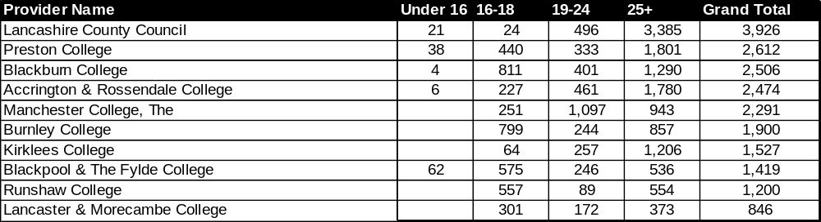
Source: LEP Data Cube

  - Looking at achievements within the delivery Data Cube, there were just under 22,500 within Lancashire in 2013/14, down from around 24,500 in 2012/13. As with the starts data, health & social care accounted for the highest share of achievements at approximately 16,700. Figures 52 and 53 provide sub-sector achievements in the entire sector in Lancashire for 2012/13 and 2013/14 respectively.
Figure 52: Health, Public Services & Care Sector Achievements in Lancashire by Sub-Sector, 2012/13
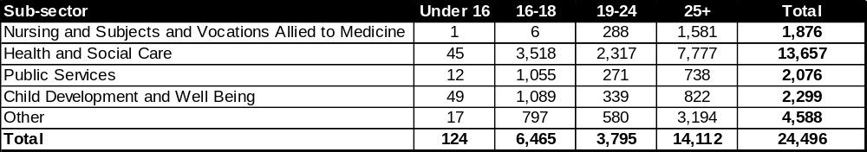
Source: LEP Data Cube

Figure 53: Health, Public Services & Care Sector Achievements in Lancashire by Sub-Sector, 2013/14
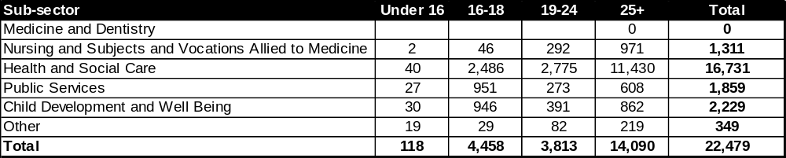
Source: LEP Data Cube

  - Looking at the different levels of achievements within the sector, in 2013/14 the highest number in Lancashire were at Level 2 (around 6,800), followed by Level 1 at just under 6,300 (see Figure 54).

Figure 54: Health, Public Services & Care Sector Achievements in Lancashire by Notional NVQ Level, 2013/14
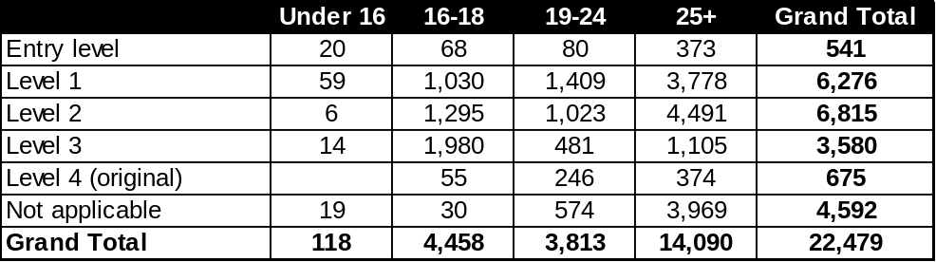
Source: LEP Data Cube

  - Lancashire County Council accounted for the most health, public services & care achievements in the LEP area in 2013/14 at around 3,700. This was followed by Preston College and Accrington & Rossendale College (both at 2,300). Figure 55 shows the top 10 provides in Lancashire LEP and combined, they accounted for 81% of all starts in the sector in 2013/14.
Figure 55: Health, Public Services & Care Sector Achievements in Lancashire, 2013/14 – 10 largest providers
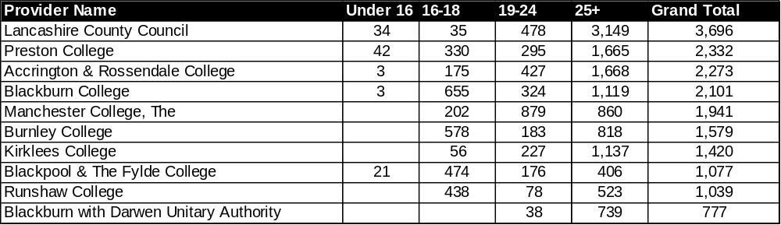
Source: LEP Data Cube

Success Rates
  - Separate data published by the SFA show the success rates (the proportion of learning successfully completed) of people on apprenticeships at a national level, broken down by subject area. Figure 56 shows success rates for health & social care apprenticeships from 2011/12-2013/14 funded by the SFA, with Figure 57 then going on to provide information for all apprenticeships.
  - It can be seen that over the three year period in question, success rates in health & social care subjects have lagged behind the overall average – for example, a success rate of 66.8% in 2013/14 for all apprenticeships in the sector (see Figure 56) was below the overall average of 68.9% (see Figure 57). More positively, success rates in health & social care subjects have remained broadly the same since 2011 whereas the overall average has declined – the average of 68.9% in 2013/14 was a substantial decline on the 73.8% recorded in 2011/12.
Figure 56: Apprenticeship success rates (national level) for health & social care subjects, 2011-2014
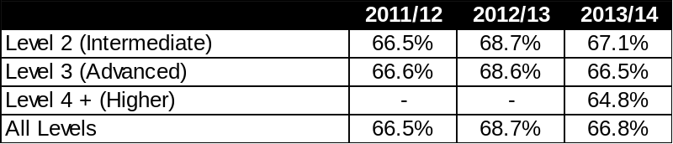
Source: SFA

Figure 57: Apprenticeship success rates (national level) for all subjects, 2011-2014
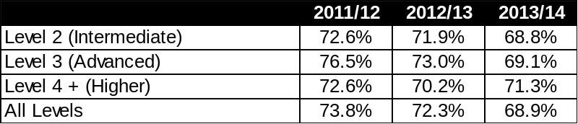
Source: SFA
UKCES Employer Skills Survey
  - The UKCES Employer Skills Survey (ESS) provides an indication of skills needs and training investment in UK businesses. The most recent ESS was undertaken in 2013 and it looked at a number of issues, including:
- Skill-shortage vacancies (SSV): These are vacancies that are hard-to-fill due to applicants not having the rights skills or work experience.
- Skills gaps: When employees do not have the right skills to be fully proficient to do their job.
  - In terms of SSV for all companies (regardless of sector), results from the ESS indicate that nationally, one in five vacancies (22.0%) are proving difficult to fill due to skills shortages. The corresponding figure for Lancashire LEP is virtually the same. The health & social work sector in Lancashire had a lower proportion of SSVs at 13%, however.
  - Looking at the results for Lancashire LEP in more detail across all sectors, the main reason cited by employers in the area for having a hard-to-fill vacancy was the low number of applicants with the required skills (45%). This was followed by a lack of work experience (31%). Figure 58 breaks the results down into further detail, providing the top 10 causes in Lancashire LEP for hard-to-fill vacancies.
Figure 58: Main causes of having a hard-to-fill vacancy in Lancashire LEP
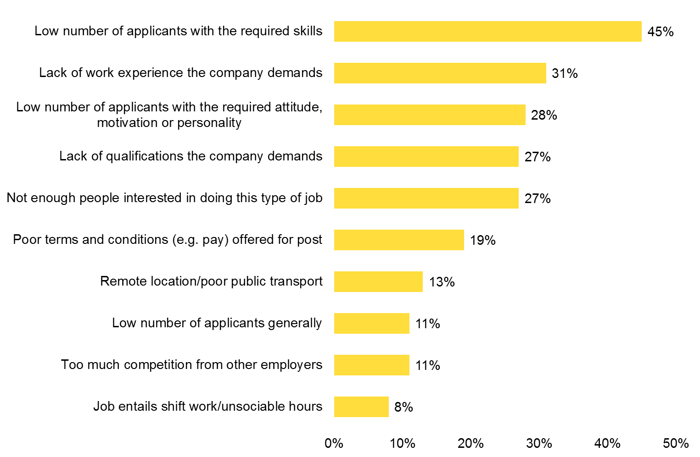
Source: ESS (UKCES, 2013)
  - The ESS also asked employers about the skills they found difficult to obtain from applicants. In Lancashire LEP, 72% of employers with an SSV citied technical, practical or job specific skills as the hardest skillsets to obtain. This was followed by planning and organisation skills (57%) and oral communication skills (49%). Team working skills, which were highlighted as being of importance in the literature review, were cited by 42% of employers (see Figure 59).
Figure 59: Skills found difficult to obtain from applicants in Lancashire LEP
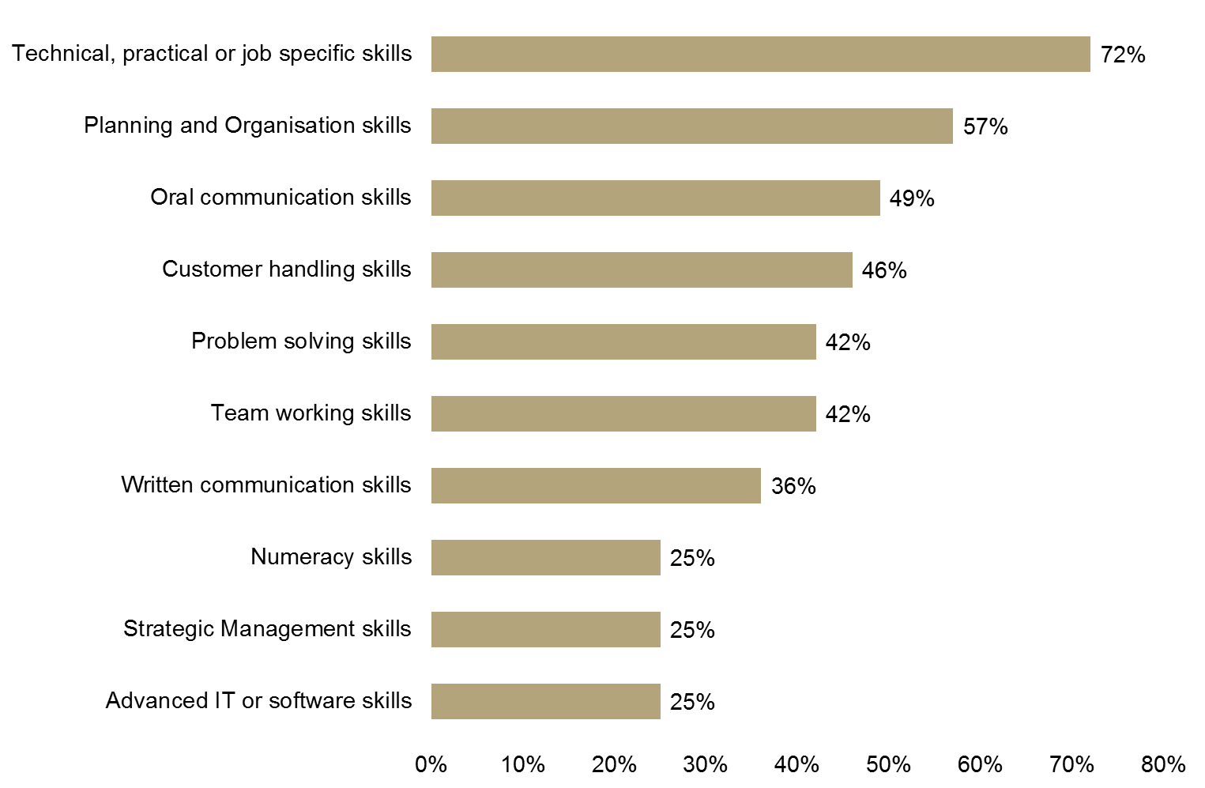
Source: ESS (UKCES, 2013)
  - In terms of skills gaps, the main cause identified by employers in Lancashire LEP was that staff training was only partially completed (63%), followed by 60% of respondents saying gaps were due to staff being new to a role (see Figure 60).
Figure 60: Causes of skills gaps in Lancashire LEP
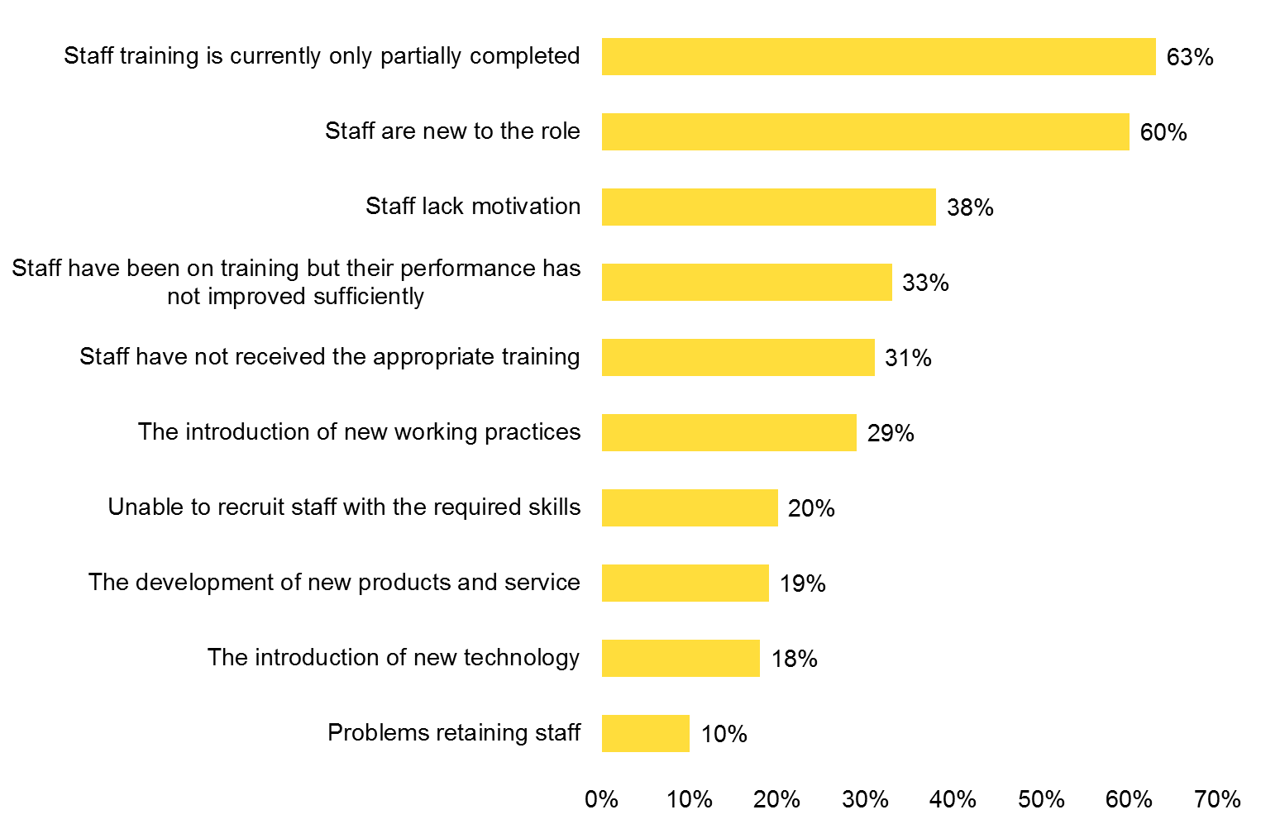
Source: ESS (UKCES, 2013)
  - Results by sector are available from the ESS, although the majority of the information is published at a national level. The main points to note for the health & social work sector nationally are (where available, Lancashire LEP figures are included too):
- There are emerging pockets of skills deficiency for professionals in the sector nationally.

- 89% of employers in the health & social work sector were likely to offer training, the third highest proportion of any sector nationally. The figure for Lancashire LEP was even higher at 93%. Moreover, 90% of employers in the health & social work sector in Lancashire predicted a need for an upskilling of staff over the next 12 months.

- 45% of employers in the sector nationally offered some form of management training, behind only education (60%) and public administration (54%).

- Health & social work employers that trained were the most likely to have trained any staff to a qualification (65%), and trained the highest proportion of their workforce to nationally recognised qualifications (24%, compared to the UK average of 13%).

- There is considerable variation in rates of recruitment of education leavers across the different sectors of the economy. In health & social work for example, 17% of employers nationally recruited from FE colleges, second only to hotels & restaurants (19%). In addition, 17% of employers in the sector said they recruited from HEIs, below the high of 38% reported for education, but still relatively high when compared to other sectors within the economy. Lancashire LEP had a similar figure at 18% in terms of recruitment by the sector from HEIs.

- A lack of work experience was particularly likely to be given as a reason for failing to employ young people by employers in the Health and Social Work – 71% at a national level – the highest proportion of any sector.

Key Issues
  - Based on the research to date, issues for consideration when engaging with employers and skills providers include:
Skills shortages
  - An ageing population will change the levels of demand placed on different aspects of the healthcare system. New technology, pharmaceutical advances, genetic engineering and emergent evidence-based medical and nursing practice requires the healthcare sector to develop new ways of working with an ageing population that will have more complex co-morbidities, be more aware of care needs and have growing expectations of what the care system should deliver them.
Skills gaps
  - Skills requirements are evolving – for example, medical training needs to move away from the traditional individualistic perspective and prepare students for multidisciplinary team working. Health and social care are team-based activities; the work of one team member is inter-dependent on others, and therefore working practices require better integration. In addition, embracing and integrating digital technologies into healthcare provision is increasingly integral to ensuring that industry professionals are equipped to adapt to these changes. Whilst there remain a number of barriers, both in terms of set-up and utilisation, digital technologies will become a vital tool for the health and social care workforce in the future.
Recruitment and retention
  - Certain areas of the health and social care sector are facing chronic employment and skills shortages. Across both Lancashire and the UK, there is a shortage of nurses, general practitioners, care workers and pharmacists, among others. Part of the reason for the lack of supply is due to the conditions in which these professionals are expected to work. A number of reports, such as Think Big, Act Now and Raising the Bar, advocate working practice reform by reducing the bureaucratic workload, investing in further training and generally valuing health and social care professional better. Analysis of the Skills for Care NMDS-SC shows that in social care, pay is well below average, which is another issue that needs to be addressed. Recruitment and retention problems will be further exacerbated by the ageing workforce – it is projected that 107,000 people will retire between 2007 and 2017 and the proportion of both GPs and nurses over the age of 50 is growing. When older members of the workforce retire, they take with them valuable skills and experience.
Investment
  - The lack of investment in continuing professional development (CPD) is particularly striking. Currently, less than 5% of the £5billion NHS training budget is allocated to CPD, while the rest is spent on securing professional qualifications. Looking further ahead, the bulk of the workforce of 2025 are already in jobs, however it appears as though their skills development needs are not being met.

Bibliography
Age UK. (2013). The ’Dilnot social care cap’: making sure it delivers for older people. Available at: http://www.ageuk.org.uk/documents/en-gb/press%20releases/implementing%20the%20dilnot%20social%20care%20cap.pdf?dtrk=true

Better Care Together. (2015). The Better Care Together Strategy: the Future for Health & Care Services in Morecambe Bay. Available at: http://bettercaretogether.co.uk/files/BCT-Vision-FINAL_for_Publication.pdf

Borrill, C. S., Carletta, J., Carter, A. J., Dawson, J. F., Garrod, S., Rees, A., Richards, A., Shapiro, D., West, M.A., (2000). The Effectiveness of Health Care Teams in the National Health Service. Aston University, University of Glasgow, University of Leeds. Available at: http://homepages.inf.ed.ac.uk/jeanc/DOH-final-report.pdf

Carers UK (2012). Facts about Carers 2012. Policy briefing. London: Carers UK. Available at: www.carersuk.org/media/k2/attachments/Facts_about_carers_Dec_2012.pdf

Cavendish C (2013) An Independent Review into Healthcare Assistants and Support Workers in the NHS and Social Care Settings. London: Department of Health, Available at: www.gov.uk/government/publications/review-of-healthcare-assistants-and-support-workers-in-nhs-and-social-care

Centre for Cities. (2015). Skills and cities – 10 years of change. Available at: http://www.centreforcities.org/blog/skills-and-cities-10-years-of-change/

Centre for Workforce Intelligence. (2014). In-depth review of the general practitioner workforce. Available at: http://www.cfwi.org.uk/publications/in-depth-review-of-the-gp-workforce/attachment.pdf

Department of Health. (2014). Transforming Primary Care: Safe, proactive, personalised care for those who need it most. Available at: https://www.gov.uk/government/uploads/system/uploads/attachment_data/file/304139/Transforming_primary_care.pdf

Health Education England. (2015). Raising the Bar - Shape of Caring: A Review of the Future Education and Training of Registered Nurses and Care Assistants. Available at: http://hee.nhs.uk/wp-content/blogs.dir/321/files/2015/03/2348-Shape-of-caring-review-FINAL.pdf

Health Education North West. (2014). Workforce transformation. Available at: https://nw.hee.nhs.uk/our-work/workforce-transformation/
Health Education North West. (2015). Care Certificate Toolkit. Available at: https://nw.hee.nhs.uk/our-work/care-certificate-toolkit/

Healthier Lancashire Programme. (2014). A Lancashire System Response to the Five Year Forward View. Available at: http://www.eastlancsccg.nhs.uk/download/governing_body_papers/6.4%20%20Healthier%20Lancashire%20Programme%20-%20Purpose%20Document.pdf

HEFCA. (2013). Higher education provision in England. Available at: https://www.hefce.ac.uk/analysis/coldspots/heprovision/

Imison, C., Buchan, J., Xavier, S. (2009). NHS Workforce Planning: Limitations and possibilities. London: The King’s Fund. Available at: www.kingsfund.org.uk/publications/nhs-workforce-planning

Institute of race relations. (2013). Poverty, Inequality, Employment and Health. Available at: http://www.irr.org.uk/research/statistics/poverty/#_edn1

Joseph Rowntree Foundation (2014). Pay, conditions and care quality in residential, nursing and domiciliary services. Available at: http://www.jrf.org.uk/sites/files/jrf/care-pay-conditions-summary.pdf

King’s College London. (2007). Will an ageing nursing workforce work? Available at: http://www.kcl.ac.uk/nursing/research/nnru/policy/Policy-Plus-Issues-by-Theme/Labourmarketdynamics/PolicyIssue2.pdf

Lancashire County Council. (2013). Lancashire's Black Minority Ethnic Communities. Available at: http://www3.lancashire.gov.uk/corporate/web/?siteid=6120&pageid=42617&e=e

National Voices. (2015). My life, my support, my choice: a vision for person centred coordinated care and support for children and young people with complex lives. Available at: http://www.nationalvoices.org.uk/sites/www.nationalvoices.org.uk/files/tlapmylifemysupportmychoice_final.pdf

Naylor, C., Mundle, C., Weaks, L., Buck, D. (2013). Volunteering in Health and Care: Securing a sustainable future. London: The King’s Fund. Available at: www.kingsfund.org.uk/publications/volunteering-health-and-care

NHS Alliance. (2014). Think Big, Act Now: Creating a Community of Care. Available at: http://www.nhsalliance.org/wp-content/uploads/2015/01/THINK-BIGACT-NOW-online-24.pdf

NHS, Skills for Care & Skills for Health. (2014). The Care Certificate. Available at: http://nwl.hee.nhs.uk/files/2014/07/Care-Certificate-briefing-and-Qs-and-As-PDF.pdf

NHS England. (2015). The NHS Five Year Forward View. Available at: http://www.england.nhs.uk/ourwork/futurenhs/

NMDS-SC. (2015). NMDS-SC Dashboard. Available at: https://www.nmds-sc-online.org.uk/Default.aspx

Nuffield Trust. (2014). The NHS and social care: quality and finance. Available at: http://www.nuffieldtrust.org.uk/sites/files/nuffield/publication/nhs_and_social_care_quality_and_finance_briefing.pdf

ONS (Office for National Statistics). (2012). Statistical First Release Apprenticeship Supplementary Tables. Available at: http://webarchive.nationalarchives.gov.uk/20140107201041/http://www.thedataservice.org.uk/NR/rdonlyres/87E140BF-810D-4C48-A5C1-9C8B84B46117/0/October2012_Apprenticeship_Starts.xls

PwC Health Research Institute. (2014). Healthcare delivery of the future: How digital technology can bridge time and distance between clinicians and consumers. Available at: http://www.pwc.com/en_US/us/health-industries/top-health-industry-issues/assets/pwc-healthcare-delivery-of-the-future.pdf

Skills For Care. (2014). Digital capabilities in the social care workforce. Available at: http://www.skillsforcare.org.uk/Document-library/NMDS-SC,-workforce-intelligence-and-innovation/Research/Digital-literacy/Digital-Capability-Rapid-Evidence-Review-300714-FINAL.pdf

Skills for Care. (2015). The state of the adult social care sector and workforce in England. Available at: http://www.skillsforcare.org.uk/Document-library/NMDS-SC,-workforce-intelligence-and-innovation/NMDS-SC/State-of-2014-ENGLAND-WEB-FINAL.pdf

Skills for Health. (2009). Tomorrow’s workforce: Commentaries on the future of skills and employment in the UK’s health sector. Available at: http://www.wales.nhs.uk/sitesplus/documents/829/skills-for-health-tomorrows-workforce.pdf

Skills for Health. (2010). Skills for Health: Skills and Labour Market Intelligence Briefing for the North West of England. Available at: http://www.skillsforhealth.org.uk/index.php?option=com_mtree&task=att_download&link_id=91&cf_id=24

Skills for Health. (2011). UK Sector Skills Assessment 2011. Available at: http://www.skillsforhealth.org.uk/index.php?option=com_mtree&task=att_download&link_id=80&cf_id=24

STV. (2015). NHS mental health waiting times progress 'not significant enough'. Available at: http://news.stv.tv/scotland/312640-nhs-mental-health-waiting-times-progress-not-significant-enough/

The Guardian. (2015). Care certificate offers an opportunity to shift health and social care culture. Available at: http://www.theguardian.com/social-care-network/skills-for-care-partner-zone/2015/feb/05/care-certificate-health-social-care-culture

The King’s Fund. (2013). NHS and social care workforce: meeting our needs now and in the future? Available at: http://www.kingsfund.org.uk/sites/files/kf/field/field_publication_file/perspectives-nhs-social-care-workforce-jul13.pdf

UKCES. (2012). Sector Skills Insights: Health & Social Care, available at: https://www.gov.uk/government/publications/health-and-social-care-sector-skills-insights

Appendix A – Health & Social Care Sector: SIC Definition
SIC Code | Description | Types of Activity Included
8610 | Hospital activities | Short- or long-term hospital activities, i.e. medical, diagnostic and treatment activities, of general hospitals ( e.g. community and regional hospitals, hospitals of non-profit organisations, university hospitals, military-base and prison hospitals) and specialised hospitals (e.g. mental health and substance abuse hospitals, hospitals for infectious diseases, maternity hospitals, specialised sanatoriums).
8621 | General medical practice activities | Medical consultation and treatment in the field of general medicine carried out by general practitioners.
8622 | Specialist medical practice activities | Medical consultation and treatment in the field of specialised medicine by medical specialists and surgeons, and family planning centres providing medical treatment such as sterilisation and termination of pregnancy, without accommodation.
8623 | Dental practice activities | Dental practice activities of a general or specialised nature, e.g. dentistry, endodontic and paediatric dentistry; oral pathology. It also includes orthodontic activities, as well as dental activities in operating rooms.
8690 | Other human health activities | Activities for human health not performed by hospitals or by medical doctors or dentists, including:  - Activities of nurses, midwives, physiotherapists or other paramedical practitioners in the field of optometry, hydrotherapy, medical massage, occupational therapy, speech therapy, chiropody, homeopathy, chiropractic, acupuncture etc.  These activities may be carried out in health clinics such as those attached to firms, schools, homes for the elderly, labour organisations and fraternal organisations and in residential health facilities other than hospitals, as well as in own consulting rooms, patients’ homes or elsewhere.  This class also includes:  - Activities of dental paramedical personnel such as dental therapists, school dental nurses and dental hygienists, who may work remote from, but are periodically supervised by, the dentist  - Activities of medical laboratories such as:  - X-ray laboratories and other diagnostic imaging centres  - Blood analysis laboratories  - Activities of blood banks, sperm banks, transplant organ banks etc.  - Ambulance transport of patients by any mode of transport including aeroplanes.
8710 | Residential nursing care activities | Activities of:  - Homes for the elderly with nursing care  - Convalescent homes  - Rest homes with nursing care  - Nursing care facilities
8720 | Residential care activities for learning disabilities, mental health and substance abuse | This class includes the provision of residential care (but not licensed hospital care) to people with learning disabilities, mental illness, or substance abuse problems. Facilities provide room, board, protective supervision and counselling and some health care. This class includes activities of:  - Facilities for alcoholism or drug addiction treatment  - Psychiatric convalescent homes  - Residential group homes for the emotionally disturbed  - Learning disabilities facilities  - Mental health halfway houses  - Nursing homes
8730 | Residential care activities for the elderly and disabled | This class includes the provision of residential and personal care services for the elderly and disabled who are unable to fully care for themselves and/or who do not desire to live independently. The care typically includes room, board, supervision, and assistance in daily living, such as housekeeping services. In some instances these units provide skilled nursing care for residents in separate on-site facilities. This class includes activities of:  - Assisted-living facilities  - Continuing care retirement communities  - Homes for the elderly with minimal nursing care  - Rest homes without nursing care
8790 | Other residential care activities | This class includes the provision of residential and personal care services for persons, except the elderly and disabled, who are unable to fully care for themselves or who do not desire to live independently. It includes:  - Orphanages  - Children’s boarding homes and hostels  - Temporary homeless shelters  - Institutions that take care of unmarried mothers and their children
8810 | Social work activities without accommodation for the elderly and disabled | This class includes:  - Social, counselling, welfare, referral and similar services which are aimed at the elderly and disabled in their homes or elsewhere and carried out by government offices or by private organisations, national or local self-help organisations and by specialists providing counselling services:  - Visiting of the elderly and disabled  - Day-care activities for the elderly or for disabled adults  - Vocational rehabilitation and habilitation activities for disabled persons provided that the education component is limited
8891 | Child day-care activities | Activities of day nurseries for pupils, including day-care activities for disabled children.
8899 | Other social work activities without accommodation not elsewhere classified | This class includes:  - social, counselling, welfare, refugee, referral and similar services which are delivered to individuals and families in their homes or elsewhere and carried out by government offices or by private organisations, disaster relief organisations and national or local self-help organisations and by specialists providing counselling services:  - Welfare and guidance activities for children and adolescents  - Adoption activities, activities for the prevention of cruelty to children and others  - Household budget counselling, marriage and family guidance, credit and debt counselling services  - Community and neighbourhood activities  - Activities for disaster victims, refugees, immigrants etc., including temporary or extended shelter for them  - Vocational rehabilitation and habilitation activities for unemployed persons provided that the education component is limited  - Eligibility determination in connection with welfare aid, rent supplements or food stamps day facilities for the homeless and other socially weak groups  - Charitable activities like fund-raising or other supporting activities aimed at social work
Appendix B
Location Quotients in Health & Social Care in Lancashire LEP Districts
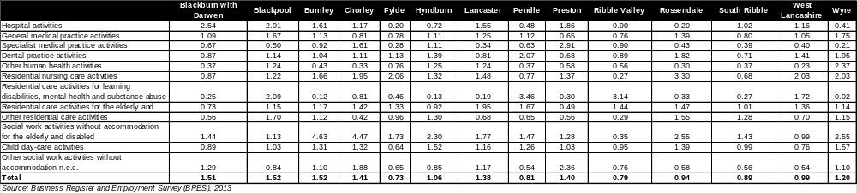
Location Quotients in Health & Social Care in Lancashire Travel To Work Areas
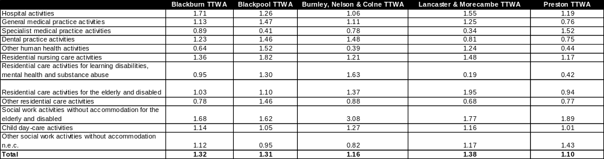

NHS England. (2015). The NHS Five Year Forward View.
Healthier Lancashire Programme. (2014). A Lancashire System Response to the Five Year Forward View.
Ibid.
Skills for Care. (2015). The state of the adult social care sector and workforce in England.
Ibid.
The King’s Fund. (2013). NHS and social care workforce: meeting our needs now and in the future?
Skills for Health. (2011). UK Sector Skills Assessment 2011.
UKCES. (2012). Sector Skills Insights: Health & Social Care.
UKCES. (2012). Sector Skills Insights: Health & Social Care.
King’s College London. (2007). Will an ageing nursing workforce work?
Centre for Workforce Intelligence. (2014). In-depth review of the general practitioner workforce.
Ibid.
Ibid.
Age UK. (2013). The ’Dilnot social care cap’: making sure it delivers for older people.
HEFCA. (2013). Higher education provision in England.
Centre for Cities. (2015). Skills and cities – 10 years of change.
Healthier Lancashire Programme. (2014). A Lancashire System Response to the Five Year Forward View.
UKCES. (2012). Sector Skills Insights: Health & Social Care.
Ibid.
Skills for Care. (2015). The state of the adult social care sector and workforce in England.
Healthier Lancashire Programme. (2014). A Lancashire System Response to the Five Year Forward View.
NMDS-SC. (2015). NMDS-SC Dashboard.
UKCES. (2012). Sector Skills Insights: Health & Social Care.
Ibid.
Ibid.
ONS (Office for National Statistics). (2012). Statistical First Release Apprenticeship Supplementary
NHS, Skills for Care & Skills for Health. (2014). The Care Certificate.
The Guardian. (2015). Care certificate offers an opportunity to shift health and social care culture.
Health Education North West. (2015). Care Certificate Toolkit.
UKCES. (2012). Sector Skills Insights: Health & Social Care.
Skills for Health. (2010). Skills for Health: Skills and Labour Market Intelligence Briefing for the North West of England.
Skills for Care. (2015). The state of the adult social care sector and workforce in England.
Healthier Lancashire Programme. (2014). A Lancashire System Response to the Five Year Forward View.
Skills for Care. (2015). The state of the adult social care sector and workforce in England.
NHS Alliance. (2014). Think Big, Act Now: Creating a Community of Care.
Borrill et al. (2000). The Effectiveness of Health Care Teams in the National Health Service. Aston University, University of Glasgow, University of Leeds. Available at: http://homepages.inf.ed.ac.uk/jeanc/DOH-final-report.pdf
The King’s Fund. (2013). NHS and social care workforce: meeting our needs now and in the future?
Ibid.
UKCES. (2012). Sector Skills Insights: Health & Social Care.
Skills for Health. (2009). Tomorrow’s workforce: Commentaries on the future of skills and employment in the UK’s health sector.
Skills for Health. (2009). Tomorrow’s workforce: Commentaries on the future of skills and employment in the UK’s health sector.
Health Education England. (2015). Raising the Bar - Shape of Caring: A Review of the Future Education and Training of Registered Nurses and Care Assistants.
Ibid.
Nuffield Trust. (2014). The NHS and social care: quality and finance.
STV. (2015). NHS mental health waiting times progress 'not significant enough'.
Department of Health. (2014). Transforming Primary Care: Safe, proactive, personalised care for those who need it most.
National Voices. (2015). My life, my support, my choice: a vision for person centred coordinated care and support for children and young people with complex lives.
Health Education North West. (2014). Workforce Transformation.
Better Care Together. (2015). The Better Care Together Strategy: the Future for Health & Care Services in Morecambe Bay.
Imison et al. (2009). NHS Workforce Planning: Limitations and possibilities.
Naylor et al. (2013). Volunteering in Health and Care: Securing a sustainable future.
Carers UK (2012). Facts about Carers 2012. Policy briefing.
The King’s Fund. (2013). NHS and social care workforce: meeting our needs now and in the future?
The King’s Fund. (2013). Volunteering in health and care: Securing a sustainable future. Available at: http://www.kingsfund.org.uk/sites/files/kf/field/field_publication_file/volunteering-in-health-and-social-care-kingsfund-mar13.pdf
Ibid.
Cavendish, C. (2013) An Independent Review into Healthcare Assistants and Support Workers in the NHS and Social Care Settings.
The King’s Fund. (2013). NHS and social care workforce: meeting our needs now and in the future?
The King’s Fund. (2014). Community services: How they can transform care. At: http://www.kingsfund.org.uk/sites/files/kf/field/field_publication_file/community-services-nigel-edwards-feb14.pdf
Ibid.
TTWA area figures are not available for the business base.
Labour Force Survey 2014
The three geographies available for Lancashire on the NMDS-SC are: Blackburn with Darwen; Blackpool and Lancashire. The analysis presents the data for these areas as an overall total.

